Table of Contents
Section 1: Introduction 4
Information Retrieval (IR) 5
Generative AI 7
Retrieval-Augmented Generation (RAG) 8
AI Agents 10
Agentic AI 12
A Real-World Evolution Example, Enterprise IT Support & Knowledge Assistant 17
PHASE 1 — Traditional Application, What the System Looks Like? 18
PHASE 2 — Information Retrieval (IR) 21
PHASE 3 — Generative AI 24
PHASE 4 — RAG (Retrieval-Augmented Generation) 27
PHASE 6 — Agentic AI 33
Full Evolution of Data 36
Layman Summary 37
Technical Summary 38
Section 2: Generative AI Fundamentals and Bedrock 41
Amazon Bedrock Overview 41
Fine-Tuning Foundation Models in Bedrock 46
LORA - Low-ranked Adaptation 49
RAG (Retrieval-Augmented Generation) 50
Vector Stores and Semantic Search 56
RAG in Bedrock: Knowledge Bases 58
AWS Bedrock Hands-On 60
🎯 One-Line Interview Answer 67
Pre-Retrieval and Chunking Strategies 69
Managing Chunking Strategies with Bedrock 70
Optimizing your Vector Store and Embeddings 71
Evaluating RAG Performance 72
Multimodal Models and Pipelines with Bedrock 73
Bedrock Guardrails 74
Bedrock Guardrails Automated Reasoning Checks 75
Token Level Redaction 76
Amazon Bedrock Prompt Management 77
Bedrock Prompt Flows 78
Enforcing Use of Structured Data 79
Intro to Prompt Engineering 80
Anatomy of a Prompt 81
Prompt Best Practices 82
Types of Prompts 83
Prompt Misuse and Mitigating Bias 84
Enterprise Integration 85
AWS Well-Architected Tool Generative AI Lens 86
Section 3: Managing Data for Generative AI 87
Dealing with Structured Data 88
Amazon Bedrock Data Automation 89
SageMaker Data Wrangler 90
AWS Glue 91
AWS Glue Studio 92
Glue Data Quality 93
CloudWatch Metrics 94
AWS Transcribe 95
Amazon Comprehend 96
Using Comprehend, Lambda, and Bedrock together 97
Amazon Comprehend Medical 98
Amazon OpenSearch (formerly Elasticsearch) 99
OpenSearch Index Management and Designing for Stability 102
Amazon Opensearch Service performance 105
Amazon Opensearch Serverless 105
Amazon S3 Vectors 116
Amazon RDS 119
Amazon Aurora 124
Amazon Dynamo DB -NoSQL Serverless Database 127
Keeping your Vector Store Up to Date 133
Re-Ranker Modules in Bedrock 136
Amazon S3 137
Amazon S3 – Replication 138
S3 Encryption 139
S3 Access Logs 140
S3 Access Points 141
Section 4: Agentic AI 142
Introduction 143
Section 5: Operational Efficiency and Optimization 144
Section 6: Managing Models with SageMaker AI 145
Section 7: More Tools for Building AI Applications 146
Section 8: Governance and QA 147
Section 9: Security, Identity, and Compliance 148
Section 10: Analytics Services you should know 149
Section 11: Compute, Container, and Customer Engagement Services You Should Know 150
Section 12: Database Services You Should Know 151
Section 13: Developer Tools Services You Should Know 152
Section 14: Machine Learning Services You Should Know 153
Section 15: Management and Governance Services You Should Know 154
Section 16: Migration and Transfer Services You Should Know 155
Section 17: Networking and Content Delivery Services You Should Know 156
Section 18: Storage Services You Should Know 157
Section 19: Notes on GenAI Architectural Trade-offs 158
References 159

Section 1: Introduction
Information and AI – Some Basics
Let us start our discussion by drawing a distinction between some common terminologies like
- Information Retrieval (IR)
- Retrieval Augmented Generation (RAG)
- Generative AI (Gen AI)
- AI Agents
- Agentic AI
A simple way to think about this is
Concept | Core Purpose | Main Capability | Typical Output
Information Retrieval (IR) | Find information | Search & ranking | Relevant documents
Generative AI | Create content | Generation | Text, code, images
RAG | Retrieve + Generate | Grounded generation | Context-aware answers
AI Agents | Perform tasks | Reason + act | Actions/workflows
Agentic AI | Autonomous goal execution | Planning + adaptation | Multi-step autonomous systems

Information Retrieval (IR)
Information Retrieval is the classical field of:
- Searching
- Indexing
- Ranking
- Retrieving relevant information from large datasets
This is the foundation behind
- Search engines
- Enterprise search
- Document search
- Recommendation retrieval systems

Core Idea:
User asks -> System finds relevant information
Example
You type: “What are the side effects of Aspirin?”
A search engine
- Searches indexed documents
- Ranks results
- Returns top matching pages
This is IR.

Traditional IR Technologies:
Keyword-based
- TF-IDF
- BM25
- Inverted indexes
Semantic Retrieval
- Embeddings
- Vector search
- ANN Search (FAISS, Pinecone, Milvus)
Architecture
Documents
↓
Indexing
↓
Search Engine
↓
Ranked Results

Generative AI
Generative AI creates new content. Instead of retrieving information, it:
- Predicts
- Synthesizes
- Generates
Usually powered by:
- LLMs
- Diffusion Models
- Transformers
Core Idea
User asks -> AI Generates a response
Example
You ask: “Write a resignation email.”
The model generates completely new text. No retrieval is necessary.
Types of Generative AI
Type | Output
Text Generation | ChatGPT
Image Generation | DALL·E
Code Generation | GitHub Copilot
Audio Generation | ElevenLabs
Video Generation | Sora
Problem with Generative AI
LLMs:
- Hallucinate
- May not know company/ private data
- May not know the recent events
- Can generate plausible but wrong answers
This limitation led to RAG.

Retrieval-Augmented Generation (RAG)
Simply put, RAG Combines IR + Generative AI and is the bridge between Search systems and LLMs.
Core Idea: Instead of relying only on model memory
Retrieve relevant information
+
Give it to the LLM
+
Generate grounded answer
A RAG Pipeline
User Query
↓
Embedding
↓
Vector Search / Retrieval
↓
Relevant Chunks Retrieved
↓
LLM Prompt Augmentation
↓
Generated Answer
Example:
You ask: “What is our Company leave policy?”
The System:
- Searches HR documents
- Retrieves relevant policy chunks
- Sends them to the LLM
- LLM generates answer grounded in company policy
Why RAG Exists
RAG Solves the below problems…
Problem | Solution
Hallucinations | Grounded context
No enterprise knowledge | Uses private documents
Stale information | Real-time retrieval
No citations | Retrieved sources
Typical RAG Use Cases
Use Case | Example
Enterprise Search | Internal knowledge assistant
Customer Support | FAQ bots
Legal AI | Contract retrieval
Healthcare | Clinical document QA
Finance | Research assistant
Note: A very Important Clarification - RAG is NOT Intelligence
RAG does NOT:
- Plan
- Reason deeply
- Autonomously act
- Execute workflows
It is still – “retrieve context -> generate answer”
That leads us to agents…

AI Agents
An AI Agent is an AI system that can:
- Reason
- Decide
- Use tools
- Execute actions
- Maintain state
- Interact with environments
Core Idea
Instead of only answering: AI Agents Observe, Think, Decide, Act, Repeat
Agent Capabilities
Capability | Example
Tool usage | Call APIs
Memory | Remember previous steps
Planning | Break tasks into subtasks
Reflection | Evaluate output
Iteration | Retry failed tasks
Example Agent
User says: “book me the cheapest flight to Berlin next month.”
Agent:
- Searches flights
- Compares prices
- Checks calendars
- Asks clarification
- Books ticket
And this is beyond RAG.

Agent Architecture
User Goal
↓
Planner
↓
Reasoning Loop
↓
Tool Calls
↓
Memory
↓
Action Execution
Difference between RAG and Agent
RAG | Agent
Retrieves information | Takes actions
Mostly single-step | Multi-step
Reactive | Goal-driven
Query-response | Workflow execution
No autonomy | Semi-autonomous

Agentic AI

AI Systems that operate autonomously towards goals using planning, reasoning, memory, tools, and adaptive execution.
Think of it as:
- Advanced agents
- Multi-agent systems
- Autonomous orchestration systems
Core Characteristics of Agentic AI
- Goal-Oriented
It is not about “answer this question”
But it is about “achieve this business objective”

- Autonomous Planning
I.e. Breaks tasks into subtasks.
Example: The Goal – Increase ad conversion by 10%
Agentic System may:
- Analyze campaigns
- Identify poor segments
- Run experiments
- Evaluate results
- Optimize bidding

- Multi-Step Reasoning
Has a continuous execution loop i.e.
Observe
- Plan
- Execute
- Evaluate
- Replan
- Tool Ecosystem
Can use:
- Databases
- APIs
- Browsers
- Code execution
- Workflows
- Vector stores
- ML Models

- Multi-agent Collaboration
Specialized Agents
  - Planner agent
  - Retrieval agent
  - Analytics agent
  - Coding agent
  - Validation agent
Agentic AI Vs AI Agents
AI Agents | Agentic AI
Single task execution | Autonomous ecosystems
Limited autonomy | High autonomy
Few tools | Many interconnected tools
Simple workflows | Dynamic orchestration
Reactive | Strategic/adaptive

Evolution Timeline
Information Retrieval
↓
Generative AI
↓
RAG
↓
AI Agents
↓
Agentic AI
Real World Analogy
Information Retrieval is like “a librarian finding books”
Generative AI is like “a writer creating content”
RAG is like “a writer using library references while writing”
AI Agent is like “an assistant who can search, call, email and organize”
Agentic AI is like “a project manager running an entire operation autonomously”

Practical Enterprise Mapping
Technology | Enterprise Example
IR | ElasticSearch enterprise search
Generative AI | Document summarizer
RAG | Internal knowledge assistant
AI Agent | Automated incident response assistant
Agentic AI | Autonomous operations platform

Important Industry Reality
Most “Agentic AI” products today are actually:
- RAG + workflows,
- or simple tool-using agents.
True Agentic AI is still emerging.

Your Projects Mapped
Based on your current work:
Your Project | Category
Enterprise Search | Information Retrieval
Knowledge Assistant | RAG
AdTech Recommendation POC | Could become Agentic AI
ML Pipelines | AI-enabled systems
GenAI Knowledge Assistant | RAG + early agentic patterns

A Very Important Mental Model
IR answers:
“What information is relevant?”
Generative AI answers:
“What content can I create?”
RAG answers:
“What relevant information should I use while generating?”
Agents answer:
“What actions should I take?”
Agentic AI answers:
“How do I autonomously achieve this goal?”
The Most Important Transition
The industry shift is moving from:
Knowledge Retrieval
→
Reasoning
→
Autonomous Execution
That transition is:
- IR → RAG → Agents → Agentic Systems.
And this is exactly why your current enterprise search and recommendation engine projects are strategically useful:
- they are natural foundations for agentic systems later.

A Real-World Evolution Example, Enterprise IT Support & Knowledge Assistant

From Simple Application → IR → GenAI → RAG → AI Agents → Agentic AI

Let us take a single real-world enterprise use-case that naturally evolves through all these stages.
We’ll use:
“Enterprise IT Support & Knowledge Assistant”
This is ideal because:
- almost every enterprise has it,
- it evolves naturally through all AI maturity stages,
- it touches search, ML, NLP, automation, agents, and autonomous systems.

PHASE 1 — Traditional Application, What the System Looks Like?
Initially, the company has:
- a ticketing portal,
- FAQs,
- static knowledge base articles,
- support engineers handling tickets manually.
Example:
- Employee raises password reset issue.
- Human support engineer resolves it.
Architecture
User
↓
Web Portal
↓
Application Backend
↓
Database
Characteristics
1. Rule-Based
Everything is hardcoded:
- forms,
- workflows,
- escalation rules.
2. No Intelligence
System does not:
- understand intent,
- reason,
- search semantically.
3. Exact Navigation Needed
Users must:
- know where to click,
- know exact keywords,
- manually browse FAQs.
4. Human-Centric Operations
Support engineers:
- read tickets,
- classify issues,
- respond manually.
5. Structured Data Dominates
Mostly:
- relational databases,
- ticket records,
- status fields,
- forms.

Motivation for Next Step
Problems emerge:
Problem | Impact
Too many tickets | High support cost
Knowledge scattered | Slow issue resolution
Hard to find information | Poor employee experience
Duplicate tickets | Inefficiency
Where ML/DL Exists Here?
Almost nowhere.
Possibly:
- simple analytics dashboards,
- rule engines,
- SQL reports.
No AI yet.

Data Characteristics
Type | Example
Structured | Ticket tables
Semi-structured | FAQ metadata
Low unstructured usage | PDFs/docs ignored

This creates demand for:
Information Retrieval.

PHASE 2 — Information Retrieval (IR)
Now the company introduces:
- enterprise search,
- ElasticSearch/OpenSearch,
- document indexing.
What Changes
Employees can now:
- search tickets,
- search knowledge articles,
- retrieve relevant documentation quickly.
Architecture
Documents
↓
Indexing Pipeline
↓
Search Engine
↓
Ranked Results

Example
User types:
“VPN not connecting after password change”
System retrieves:
- KB articles,
- similar historical tickets,
- troubleshooting steps.
Benefits to Users
1. Faster Discovery
No need to manually browse portals.
2. Centralized Knowledge
Search across:
- PDFs,
- Confluence,
- SharePoint,
- Jira,
- tickets.
3. Reduced Duplicate Tickets
Users self-serve more often.
4. Better Support Productivity
Engineers find historical resolutions faster.
5. Improved Ranking
Relevant results appear first.

Motivation for Next Step
IR still has limitations.
Users complain:
- “I got 20 documents… which one solves my problem?”
- “Search results are overwhelming.”
- “I still need to read everything.”
The system retrieves information,
but does not:
- summarize,
- explain,
- converse.
This creates demand for Generative AI.
Where ML/DL Comes In
Now ML starts appearing.
Classical ML
- ranking optimization,
- recommendation systems,
- click-through prediction.
NLP
- stemming,
- tokenization,
- query expansion.
Deep Learning
Semantic search starts emerging:
- embeddings,
- transformers,
- vector similarity.
Data Transformation
Data evolves from:
Structured records
→
Indexed searchable documents
Now enterprise data becomes:
- searchable,
- chunked,
- metadata enriched.

PHASE 3 — Generative AI
Now the enterprise introduces:
- LLM chatbot,
- conversational assistant.

What Changes
Instead of:
“Here are 10 documents”
The system now says:
“Your VPN issue is likely caused by expired credentials. Here are the steps…”

Architecture
User Query
↓
LLM
↓
Generated Response
Benefits
1. Natural Language Interaction
Users converse naturally.

2. Summarization
Long technical docs become concise answers.

3. Conversational UX
Feels like chatting with a human assistant.

4. Reduced Cognitive Load
Users no longer read multiple documents.

5. Faster Resolution
Answers arrive immediately.

Motivation for Next Step
Huge problem appears:
Hallucination
The LLM:
- invents steps,
- gives outdated policies,
- cannot access internal systems reliably.
Users lose trust.
The enterprise says:
“We need grounded enterprise answers.”
This leads to:
RAG.

Where ML/DL Comes In
This phase is heavily DL-driven.
Deep Learning Technologies
- Transformers
- LLMs
- GPT models
- Attention mechanisms
- Fine-tuning
- RLHF

Data Transformation
Data evolves further:
Documents
→
Embeddings
→
Semantic vector space
Now data becomes:
- machine-understandable semantically,
- represented numerically as vectors.

PHASE 4 — RAG (Retrieval-Augmented Generation)
Now the enterprise combines:
- retrieval,
- enterprise knowledge,
- LLM reasoning.

What Changes
Before answering:
- system retrieves relevant internal documents,
- injects them into prompt,
- LLM generates grounded response.
Architecture
User Query
↓
Embedding Model
↓
Vector Database
↓
Relevant Chunks
↓
LLM Prompt
↓
Grounded Answer
Example
User asks:
“How do I configure VPN after password reset?”
System:
- retrieves latest internal SOP,
- references company-specific configs,
- generates accurate answer.
Benefits
1. Enterprise Knowledge Awareness
Uses company documents.

2. Reduced Hallucination
Answers grounded in retrieved evidence.

3. Real-Time Freshness
No retraining required.

4. Citations & Explainability
Can show sources.

5. Trust Improves Dramatically
Users trust grounded responses.

Motivation for Next Step
Still limited.
RAG only:
- answers questions,
- retrieves information.
Users now want:
“Don’t just tell me how to fix VPN. Fix it.”
This creates demand for:
AI Agents.
Where ML/DL Comes In
Now the stack includes:
Area | Technology
Embeddings | Transformer models
Retrieval | Vector similarity
Ranking | Learning-to-rank
Generation | LLMs
NLP | Semantic chunking

Data Transformation
Data now becomes:
Documents
→ Chunks
→ Embeddings
→ Context Windows
Enterprise knowledge becomes:
- dynamically retrievable,
- contextualized,
- prompt-ready.

PHASE 5 — AI Agents
Now the system becomes action-oriented.
What Changes
Instead of:
“Here’s how to reset VPN”
Agent now:
- verifies identity,
- calls IAM APIs,
- resets credentials,
- updates ticket,
- sends confirmation email.
Architecture
User Goal
↓
LLM Reasoning
↓
Tool Selection
↓
API Calls
↓
Action Execution
Benefits
1. Task Completion
Not just answering — executing.

2. Workflow Automation
Handles multi-step workflows.

3. Tool Usage
Uses:
- APIs,
- databases,
- automation scripts.

4. Reduced Human Intervention
Support engineers handle only exceptions.

5. Context Retention
Agent remembers workflow state.

Motivation for Next Step
Agents still:
- operate within narrow workflows,
- require orchestration,
- struggle with complex business goals.
Now enterprise wants:
“Autonomously optimize IT operations.”
This creates:
Agentic AI.

Where ML/DL Comes In
Now multiple AI systems collaborate.
Includes
- LLM reasoning,
- planning models,
- reinforcement learning,
- workflow optimization,
- memory systems,
- orchestration frameworks.

Data Transformation
Data evolves again:
Knowledge
+
Operational telemetry
+
Tool outputs
+
Execution history
+
Memory state
Now data becomes:
- dynamic,
- continuously updated,
- operational.

PHASE 6 — Agentic AI
Now the system behaves like:
Autonomous IT Operations Manager
What Changes
System can now:
- monitor incidents,
- predict failures,
- coordinate multiple agents,
- prioritize tasks,
- self-heal infrastructure.
Example Scenario
Agentic system notices:
- repeated VPN failures,
- spike in authentication latency,
- unusual login patterns.
It:
- investigates logs,
- correlates telemetry,
- identifies root cause,
- patches configuration,
- informs teams,
- updates documentation,
- retrains anomaly model.
Without humans initiating steps.

Architecture
Goal
↓
Planner Agent
↓
Specialized Agents
↓
Tool Ecosystem
↓
Continuous Feedback Loop
↓
Adaptive Replanning
Benefits
1. Autonomous Operations
Minimal human supervision.

2. Continuous Optimization
System improves workflows dynamically.

3. Predictive Problem Solving
Acts before incidents escalate.

4. Multi-Agent Collaboration
Different agents specialize in:
- retrieval,
- remediation,
- analytics,
- validation.

5. Business-Level Outcomes
Focus shifts from:
- tickets,
to:
- operational efficiency.

Where ML/DL Comes In
This phase uses the entire AI stack.
Capability | AI Area
Planning | LLM reasoning
Prediction | ML forecasting
Root cause analysis | Graph ML
Optimization | Reinforcement learning
Anomaly detection | Deep learning
Coordination | Multi-agent systems

Full Evolution of Data
Stage 1 — Application Era
Rows & tables

Stage 2 — IR Era
Indexed searchable documents

Stage 3 — GenAI Era
Semantic embeddings

Stage 4 — RAG Era
Contextual knowledge chunks

Stage 5 — Agent Era
Operational + contextual + workflow state

Stage 6 — Agentic AI Era
Living enterprise memory system
Where:
- knowledge,
- telemetry,
- actions,
- outcomes,
- feedback loops,
continuously evolve.
The Biggest Evolution
The evolution is NOT just about smarter AI. It is actually:
Era | Primary Value
Application | Digitization
IR | Discoverability
GenAI | Communication
RAG | Grounded intelligence
Agents | Action execution
Agentic AI | Autonomous goal achievement

Layman Summary
Traditional App
A website where humans do everything manually.
Information Retrieval
A smart search engine helps find documents faster.
Generative AI
An AI assistant explains information conversationally.
RAG
The AI now answers using company-approved knowledge.
AI Agents
The AI starts performing tasks for users.
Agentic AI
The AI becomes an autonomous digital operations manager.

Technical Summary
Evolution of Capability
CRUD Systems
→
Search & Ranking
→
Neural Generation
→
Retrieval-Grounded LLMs
→
Tool-Using Autonomous Agents
→
Goal-Driven Multi-Agent Systems

Udemy Notes:

Core Concepts:

- How Bedrock Works
- How to explore models in Bedrock

- How to fine tune Foundation models
- What are the different techniques

- How bedrock support multi-modal models and pipelines
(for combining text, images and more ?)
- What are multi-modal models?
- When to use them ?
- real-world use cases

- Retrieval Augmented GEneration (RAG)

- Vector Stores and Knowledge Bases

- Chunking Strategies

- Embeddings

- Guardrails

- Token-level Redaction

- Prompt management
- Prompt Engineering
* Types of Prompts
* How to mitigate misuse and bias
* Structuringprompts with prompt flows and response structure template

- Enterprise Integration patterns

Section 2: Generative AI Fundamentals and Bedrock

Amazon Bedrock Overview

- Contains Foundation Models
* are giant pre-trained transformer models that are tuned for specific tasks,
or applying to new applications

- Ex. GPT-n (Open AI), Claude (Anthropic), DALL-E (Open AI, Microsoft)

- AWS Foundation Models (Base models)
* Jurassic-2
- Multilingual LLMs for text generation
- Support Spanish, French, German, Portuguese, Italian, Dutch

* Claude (Antrhopic)
- LLMs for conversations
- Questn Answering
- Workflow Automation

* Stable Diffusion
- Image, art, logo, design generation

* Amazon Titan
- Text Summarization
- Text Generation
- Q & A
- Embeddings
* Personalisation
* Search
* Amazon Nova Reels

- So Amazon Bedrock
- provides a single API for generative AI Foudnation Models
* Where you can invoke chat, text or image models
* can pre-build your own fine-tuned models, own models
* supports third party models
* Support for RAG
* Support for LLM Agents
- is Serverless
- can integrate with Sagemaker canvas

- The bEdrock API endpoints
* helps manage, deploy and train models
* bedrock-runtime: perform inference
(executes prompts, generate embeddigns) against these models
* bedrock-agent: Manage, deploy, train LLM agents and knowledge bases

* bedrock-agent runtime: Perform inference against agents and knowledge bases
invokeAgent, Retrieve, RetrieveAndGenerate

Note:
In the context of artificial intelligence, here's an overview of agents, LLM (Large Language Model) agents, and AI agents, along with their differences:

Agents:
An agent is a system that can perceive its environment and take actions to maximize its chances of success at some goal. Traditionally, agents operate independently and can include various AI systems designed to perform specific tasks.

LLM Agents:
LLM agents refer specifically to agents built on large language models. These agents leverage the capabilities of LLMs to understand and generate human-like text. They can answer queries, summarize information, or perform other text-based tasks. LLM agents often incorporate additional tools to enhance their capabilities, such as APIs for accessing real-time data or performing tasks.

AI Agents:
AI agents can refer broadly to any system that uses artificial intelligence to perform tasks. This includes not only LLM agents but also other types of agents like computer vision systems, rule-based systems, and even specialized agents designed for particular workflows.

Differences:

The main distinction lies in their capabilities and focus. While all LLM agents are a type of AI agent, not all AI agents are LLM agents. LLM agents are specialized for natural language processing tasks, whereas AI agents can encompass a wider range of functionalities beyond just language tasks.

Through these distinctions, you can see how they fit into the broader landscape of AI applications, especially as we move toward more sophisticated multi-agent systems where different agents can collaborate on tasks by leveraging their specialized skills.

Bedrock IAM Permissions
- Use an IAM user for access
- User must have relevant Bedrock Permissions
* AmazonBedrockFullAccess, AmazonBedrockReadOnly

- Model Access - Check if you have to reques access and the pricing too !

Bedrock Playground

Amazon Bedrock -> Chat / Text Playground -> Claude 4 -> Global Claude Sonnet 4

Mode = Chat
Configurations
- System Prompts
Ex. Always respond in the style of a pirate
- Model Reasoning
- When enabled: Generate a response's chain of thought prior to final
conclusion

- Length: Maximum Output tokens - max number of tokens to generate the
response

- Stop sequences: Specifies sequences of characters that will cause the
model to stop generating

- Randomness and diversity
- Control by
* Temperature : defines the amount of randomness, when 0 -> it will always pick the top result
* Top P: Probability threshold for the next candidate to be correct
* Top K

- Guardrails - are used to implement applicatiopn specific safeguards based on use-cases and reponsible AI policies

- Prompt Caching

Fine-Tuning Foundation Models in Bedrock

Finetuning
Definition: Fine-tuning adapts a pre-trained model (like GPT or LLaMA) by retraining it on a smaller, domain-specific dataset.
Key Benefits:
  - Customization: Tailors the model to specific tasks (e.g., legal text summarization, medical diagnosis).
  - Improved performance: Learns domain-specific language, style, or task-specific reasoning.
  - Transfer learning efficiency: Builds on general knowledge already learned.
Use Cases: Sentiment analysis, specialized chatbots, legal/medical assistants, or creative writing tools requiring a unique tone.
Fine-tuning in Bedrock
- is basically extending the training of an underlying model
- needed to adapt an existing large language model to your specific usecase
- Additional training using your own data - potentially lots of it
* Eliminates the need to build up a big conversation to get the
results you want (prompt engineering / prompt design)
* Saves on tokens in the long run
- The fine-tuned model can be used like any other model
- can keep tuning a fine-tuned model, making it smarter

Applications:
- Chatbot with a certain personality or style, or with a specific objective
like customer support, etc)
- Training with data more recent than what the LLM had
- Traning with proprietary data (your past emails or messages, customer support
transcripts)
- spcific applications such as classification, evaluating truth

Note: Not all the models in AWS bedrock can be finetuned - Check before trying

Now, how'd you finetune?
- Text Models: provide labeled training pairs of prompts and completions
which depict on how we want the questions to be answered
* they can be questions and answers
* upload training data into S3
- Image Models: Provide pairs of S3 images paths to image descriptions (prompts)
* used for text-to-image or iamge-to-embedding models.

- If you want to do this in a secure manner
* use a VPC and PrivateLink for sensitive training data

- Create a custom model in bedrock and then use a VPC and a provate link to connect and train the model

Continued Pre-training:
- Like fine-tuning, but with unlabeled data (raw data)
- Just feed the model text to familiarize the model with the data
- no need to include it into the prompts

HOw fine-tuning works under the hood ?

LORA - Low-ranked Adaptation
(Check ths out - also from AWS Bedrock perspective)

Retrieval Augmented Generation (RAG)
-

- Embeddings

- Semantic Search

- Vector Stores

- Hallucinations

-

RAG (Retrieval-Augmented Generation)

What is RAG (Retrieval-Augmented Generation)?
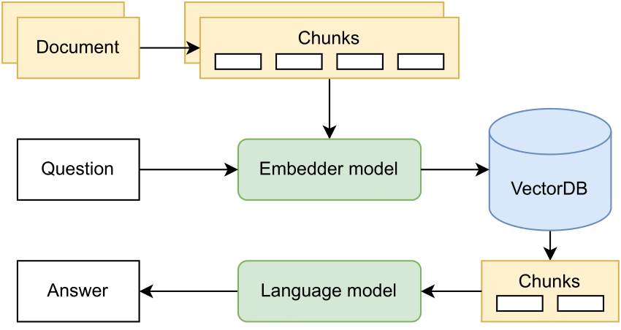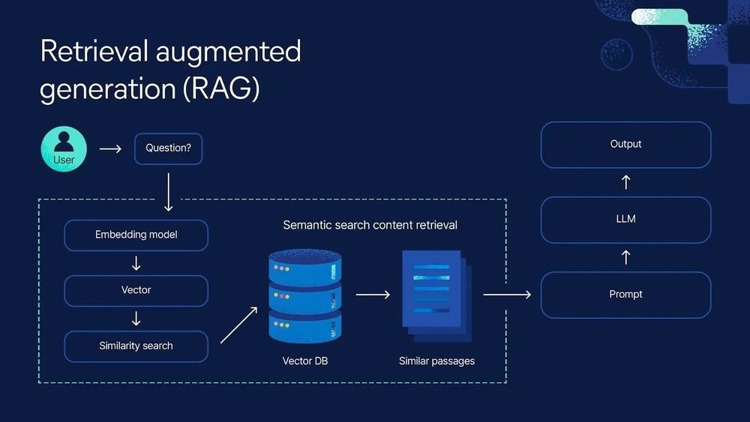
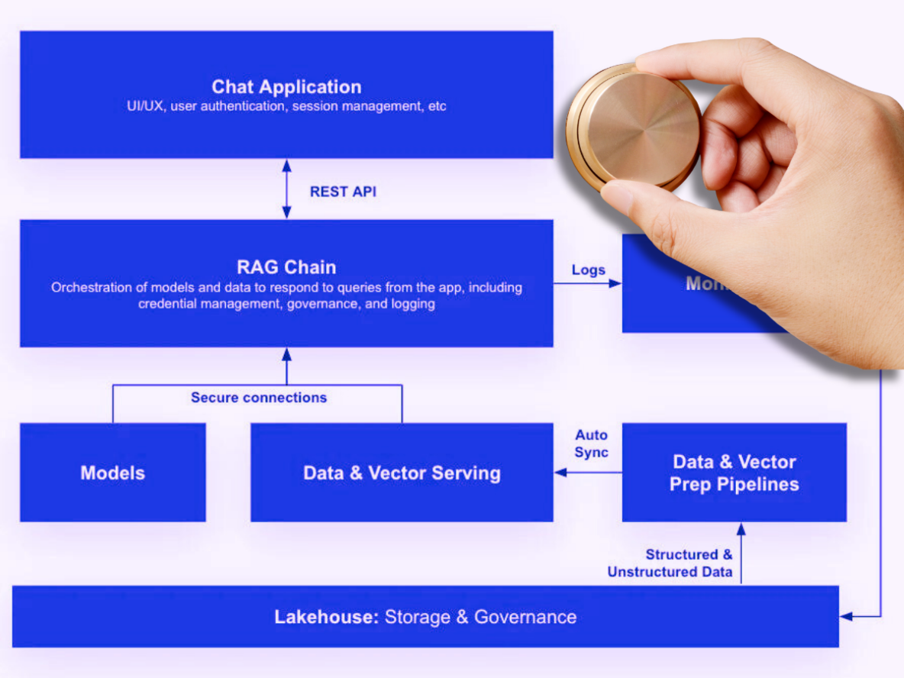
Retrieval-Augmented Generation (RAG) is an architecture pattern for AI systems where a Large Language Model (LLM) generates answers after first retrieving relevant information from an external knowledge source (documents, databases, APIs).
In short:
RAG = Retrieve facts first → then Generate an answer grounded in those facts
🧠 Why RAG exists
LLMs:
- Have fixed knowledge (training cutoff)
- Can hallucinate
- Cannot natively access private or proprietary data

RAG solves this by:
- Injecting fresh, factual, domain-specific context
- Keeping the base model unchanged
- Improving accuracy, trust, and auditability

🧩 Core Components of RAG
1️⃣ Knowledge Source
- PDFs, Word docs, Confluence pages
- Databases (Snowflake, PostgreSQL)
- Logs, policies, contracts
- Internal wikis, feature specs
2️⃣ Chunking & Embeddings
- Documents are split into chunks
- Each chunk is converted into a vector embedding
- Stored in a vector database
Examples:
- FAISS, OpenSearch, Pinecone, Weaviate
- Snowflake Cortex, pgvector
3️⃣ Retrieval (at Query Time)
When a user asks a question:
- The query is embedded
- A semantic search finds the most relevant chunks
- Top-K results are returned
This is meaning-based, not keyword-based.
4️⃣ Augmented Prompt
The retrieved content is inserted into the LLM prompt:
System Prompt: You are a financial risk analyst.
Context:
[Retrieved policy excerpt]
[Retrieved transaction example]
User Question: Is this transaction likely fraudulent?
5️⃣ Generation
The LLM:
- Uses both the prompt + retrieved facts
- Produces a grounded, contextual answer
- Often includes citations or references

🔄 End-to-End RAG Flow (Simple)
User Question
↓
Embed Question
↓
Vector Search (Retrieve relevant docs)
↓
Augment Prompt with retrieved context
↓
LLM Generates Answer

📌 RAG vs Fine-Tuning (Interview Favourite)
Aspect | RAG | Fine-Tuning
Uses external data | ✅ Yes | ❌ No
Updates knowledge easily | ✅ Instant | ❌ Retrain required
Risk of hallucination | Low | Medium
Cost | Low–Medium | High
Governance & audit | Strong | Weak
Best for enterprise data | ✅ | ❌

👉 Most enterprises prefer RAG over fine-tuning for knowledge grounding.
RAG: Pros and Cons
- Faster and Cheaper way to incorporate new or proprietary information into the “Gen AI” compared to finetuning. (Don’t have to retrain the model or re-tune the model)
- But increases the number of tokens and over a period of time may be expensive
- Updating information is just a matter of updating a database
- It can also take advantage of the “Sematic Search” via vector stores
  - Use Vector database to encode the text with its meanings and then use it
- Can prevent “hallucinations” especially when you ask the model about something it wasn’t trained on. Build in a mechanism to just say “I don’t know”
- Can use it to build “AI Search”!!

Cons:
- Increases complexity (sometimes)
- Very sensitive to the prompt template
- Is non-deterministic (temperature control makes it more deterministic)
- It can still hallucinate
- Can be very sensitive to the relevancy of the information you retrieve

Vector Stores and Semantic Search

The database is always chosen appropriate for the type of the data we are retrieving
- Graph Database (i.e. Neo4j) for retrieving product recommendations or relationships between items
- OpenSearch or something for traditional text search

Vector Databases store the embeddings

Embeddings:
- An embedding is just a big vector associated with your data.
- Think of it as a point in multi-dimensional space
- Embeddings are computed such that items that are similar to each other are close to each other in that space
  - Example: the embeddings potato and rhubarb may be closer to each other as they may have some similar characters
- We can use embedding base models (like titan) to compute them en masse
- How to store embeddings?
  - Using a vector database (explore this further)
- How retrieval looks like?
  - Compute an embedding vector for the “thing” you want to search for
  - Query the vector database for the top items close to that vector
  - You get the top-N most similar things (K-Nearest neighbor)
  - Is then called “Vector Search”
Note: How do you search the vector database for the embedding you are looking for? Do a linear search in all the vectors in the database for the term!! There are optimizations that you can employ to narrow things down to the embedding / similar / nearest embedding you are looking for (Check this out)
Examples of Vector Databases:
- Coercing existing databases to do vector search
  - Opensearch / Elastisearch, SQL, Neptune, Redis, MongoDB, Cassandra are all adapted to the world of vector databases and semantic search as an option
- Purpose-built vector DBs
  - Pinecone, weaviate
  - Chroma, marqo, Qdrant, LanceDB, Milvus, vectordb(opensource)

Check these out
- Semantic Search
- Vector Database
- Hallucinations
- Foundation Models: Can I build one?
- Find a basic use case for a RAG and implement it!

RAG in Bedrock: Knowledge Bases

Knowledge Base: is a fully managed RAG abstraction provided by AWS that let you connect your enterprise data to foundation models without building a custom RAG pipeline from scratch.
In simple terms:
A Bedrock Knowledge Base = managed ingestion + managed embeddings + managed retrieval + managed prompt grounding.
- You can upload the documents or structured data (via S3, or a JSON schema) into knowledge base
  - Some of the other sources could be web crawler, confluence, salesforce, sharepoint
- Then, the document needs to be converted / computed into embeddings vectors and they needs to be stored into a vector store of some sort .
- Bedrock provides embedding models (a foundation model) to compute the embeddings . Ex. Cohere or Amazon Titan
- These embeddings are stored in a vector store after the long data are broken into chunks through chunking before converting them into vectors or vector embeddings

Note:
- Chunking: ???
- Semantic Search:???

Using Knowledge Bases:
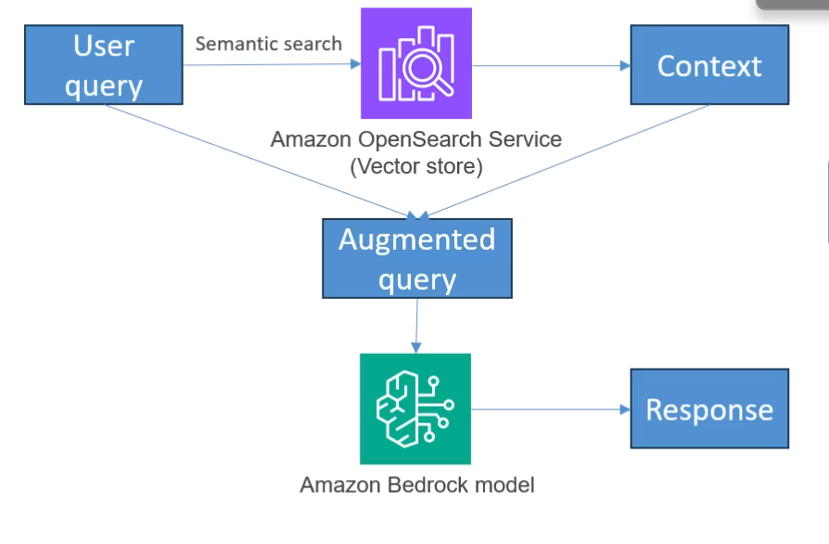

- Can incorporate knowledge bases into agents – Agentic RAG

AWS Bedrock Hands-On

Conceptual Definition (Interview-Ready)
A Knowledge Base in Amazon Bedrock is a managed service that ingests documents from data sources like S3, converts them into vector embeddings, stores them in a vector database, and automatically retrieves relevant content at inference time to ground responses from Bedrock foundation models.
What Problem Does It Solve?
Without a Knowledge Base, you must manually build:
- Document ingestion pipelines
- Chunking logic
- Embedding generation
- Vector storage
- Retriever orchestration
- Prompt grounding
Knowledge Bases remove that operational burden while enforcing AWS security and compliance standards.
High-Level Architecture
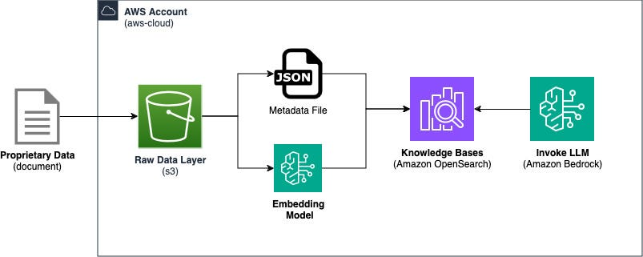
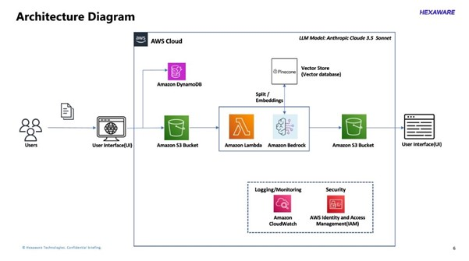
Flow
- Documents land in Amazon S3
- Bedrock:
  - Chunks documents
  - Generates embeddings (Titan)
  - Stores them in a vector store
- At query time:
  - Query is embedded
  - Relevant chunks retrieved
  - Context injected into the prompt
- LLM generates a grounded response

What’s Inside a Bedrock Knowledge Base?
1. Data Sources
- S3 (primary supported source)
- Structured or unstructured docs (PDF, TXT, HTML, DOCX)

2. Chunking & Parsing (Managed)
- Automatic chunking
- Overlap handled internally
- Metadata extracted automatically
Principal insight
This is opinionated chunking — great for speed, limited for deep customization.

3. Embeddings
- Uses Amazon Titan Embeddings (managed)
- You don’t control model internals
- Optimized for retrieval, not generation

4. Vector Store (Managed or Integrated)
Supported backends:
- Amazon OpenSearch Service (vector engine)
- Amazon Aurora (pgvector)

5. Retrieval & Prompt Grounding
- Similarity search
- Context injection
- Optional citation support
- Guardrails-compatible

How You Use It (Practically)
Without Knowledge Base
You:
- Build ingestion pipeline
- Generate embeddings
- Store vectors
- Write retriever
- Inject prompt context

With Knowledge Base
You:
- Point to S3
- Choose vector store
- Call RetrieveAndGenerate API
Knowledge Base vs Custom RAG (Very Important Table)
Feature | Bedrock Knowledge Base | Custom RAG
Setup time | Minutes | Days–weeks
Chunking control | Limited | Full
Embedding model | Fixed (Titan) | Any
Vector DB | OpenSearch / Aurora | Any
Prompt control | Partial | Full
Scaling | Managed | You
Compliance | Built-in | You
Flexibility | Medium | High

When SHOULD You Use Bedrock Knowledge Bases?
✅ Internal enterprise search
✅ Document Q&A
✅ Policy & compliance assistants
✅ Faster time-to-market
✅ Teams without deep ML infra expertise
When You SHOULD NOT Use It?
❌ Need custom chunking strategies
❌ Need hybrid retrieval (BM25 + vector)
❌ Need reranking models
❌ Multi-stage reasoning chains
❌ Cross-document reasoning workflows
Principal-level takeaway
Knowledge Bases are optimized for 80% use cases, not deep ML customization.

How Interviewers Expect You to Explain It (30-sec Answer)
A Knowledge Base in AWS Bedrock is a managed RAG service that ingests enterprise documents from S3, creates embeddings using Titan models, stores them in a vector database, and automatically retrieves relevant context to ground LLM responses using the RetrieveAndGenerate API.

One-Line Differentiator (Staff/Principal)
Bedrock Knowledge Bases trade flexibility for speed, security, and operational simplicity.

🏦 Real-World Example (Financial Services)
Use Case: Wealth Management Knowledge Assistant
Question:
“What are the eligibility rules for margin trading for senior citizens?”
RAG Flow:
- Retrieve latest policy PDFs + compliance rules
- Inject exact clauses into prompt
- Generate a precise, compliant answer
- Optionally show source document links
✅ No hallucination
✅ Fully auditable
✅ Always up-to-date

🧠 Advanced RAG Variants (Principal-Level)
- Hybrid Retrieval: keyword + vector search
- Re-ranking models (cross-encoders)
- Multi-hop RAG (chain of retrievals)
- Tool-augmented RAG (DB queries + APIs)
- Agentic RAG (planner → retriever → verifier)
- RAG + Structured Data (SQL + docs)
⚠️ Common Failure Modes (Interview Gold)
- Poor chunking → irrelevant context
- Too much context → prompt overflow
- Stale embeddings → outdated answers
- Retrieval recall issues → partial truth
- No grounding → still hallucinates

🎯 One-Line Interview Answer
- RAG is an architecture where an LLM retrieves relevant, external knowledge at inference time and uses it to generate grounded, accurate, and auditable responses—without retraining the model.

RAG: Pros and Cons

Questions:
How Chunking technique will affect the result?

Pre-Retrieval and Chunking Strategies

Managing Chunking Strategies with Bedrock

Optimizing your Vector Store and Embeddings

Evaluating RAG Performance

Multimodal Models and Pipelines with Bedrock

Bedrock Guardrails

Bedrock Guardrails Automated Reasoning Checks

Token Level Redaction

Amazon Bedrock Prompt Management

Bedrock Prompt Flows

Enforcing Use of Structured Data

Intro to Prompt Engineering

Anatomy of a Prompt

Prompt Best Practices

Types of Prompts

Prompt Misuse and Mitigating Bias

Enterprise Integration

AWS Well-Architected Tool Generative AI Lens

Section 3: Managing Data for Generative AI

Dealing with Structured Data

Amazon Bedrock Data Automation

SageMaker Data Wrangler

AWS Glue

AWS Glue Studio

Glue Data Quality

CloudWatch Metrics

AWS Transcribe

Amazon Comprehend

Using Comprehend, Lambda, and Bedrock together

Amazon Comprehend Medical

Amazon OpenSearch (formerly Elasticsearch)

- Best for analysis of large-scale (petabyte scale) analysis and reporting
- Is a fork of Elasticsearch and Kibana
  - Kibana is the visualization tool (think dashboards = think Kibana)
  - Beats is the data ingestion tool
- OpenSearch is fundamentally a search engine, an analysis tool
- Built on top of Lucine
- Can also be used to store semi-structured data and a dashboard can be built upon it for analytics
- Can also be used as a data pipeline (where Kinesis replaces Beats and LogStash)

- Is an important backend vector store used with Bedrock Knowledge Bases
- Started as a search engine now finds application in Petabyte-scale analysis and reporting
What is OpenSearch?
- A fork of ElasticSearch and Kibana where Kibana was the visualisation tool
- Fundamentally still a fast, scalable search engine
- Is an Analysis tool and a visualisation tool
- Can store semi-structured data
- Also serves as a data pipeline (Kinesis replaces the Beats and Logstash from its earlier avatar)
OpenSearch Applications
- Full-text search
- Log Analytics
- Application Monitoring
- Security Analytics
- Clickstream Analytics

What are Dashboards?

OpenSearch Applications
- Full-text Search
- Log Analytics (Ex. Adobe)
- Application Monitoring
- Security Analytics
  - Allows you to centralize and analyse data from across the organization
- Clickstream Analytics

Opensearch Concepts
- Three different entities we need to think in terms of how Opensearch works..

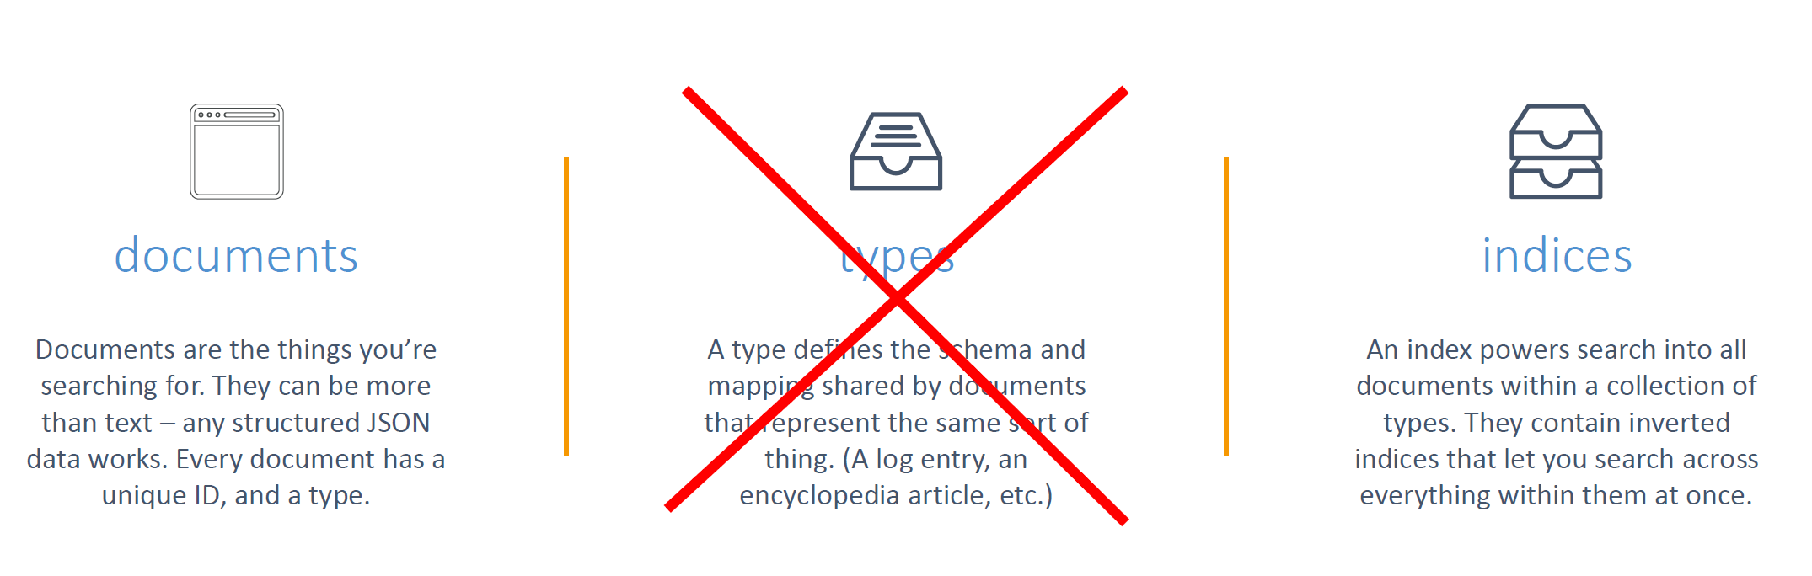
Note: Types will be deprecated => it will support any or all kinds of data

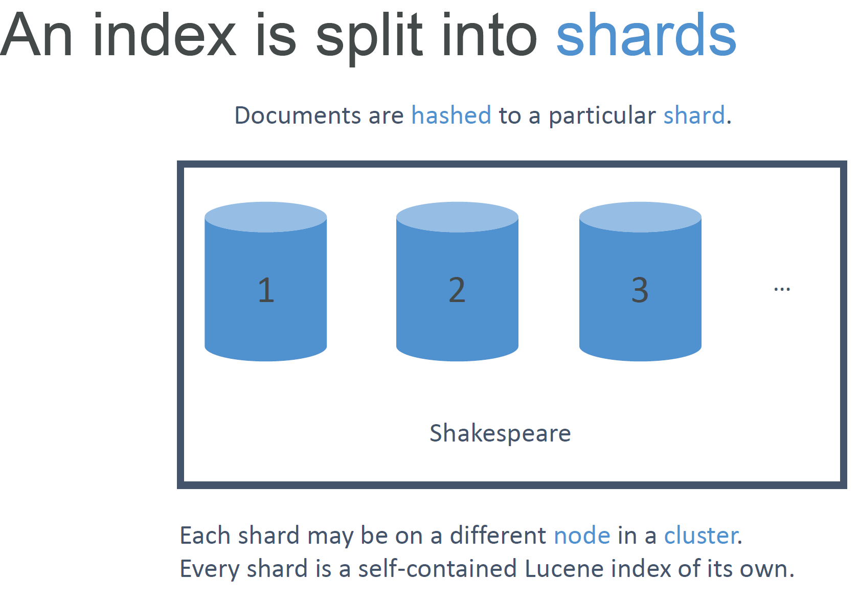

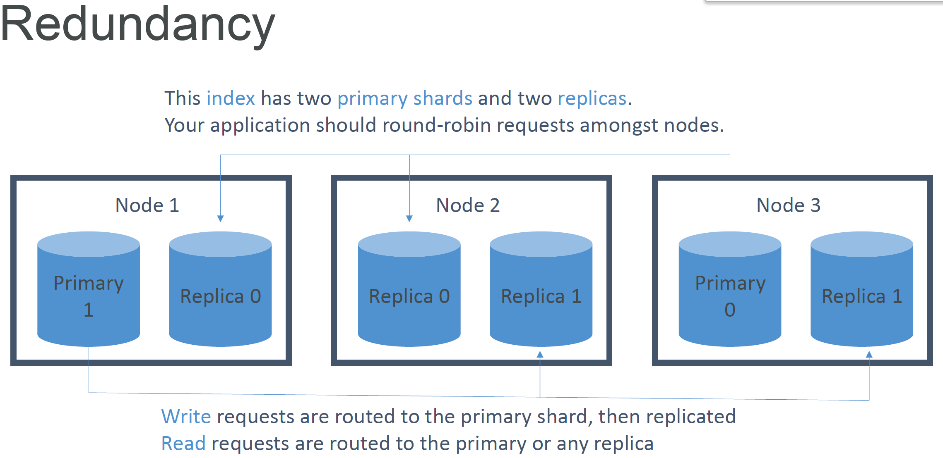

Where you cannot use Opensearch i.e. Antipatterns
Note: Refer to AWS Big Data Whitepaper
OLTP
- No transactional support
- Better to use RDS or DynamoDB
Ad-hoc data Querying
- Athena is better

Note: Remember Opensearch is primarily for Search and Analytics

OpenSearch Index Management and Designing for Stability

Storage Types in Opensearch
Cold / Warm / Ultrawarm / Hot Storage
- Standard data nodes use “hot” storage
  - Instance stores or EBS volumes / fastest performance
- UltraWarm (warm) storage uses S3 + Caching
  - Best for indices with few writes (like log data / immutable data)
  - Slower performance but much lower cost
  - Must have a dedicated master node
- Cold Storage
  - Also uses S3 and is cheaper
  - Used for “periodic research or forensic analysis on older data”
  - Must have dedicated master and have ultrawarm enabled too
  - No compatible with T2 or T3 instance types on data nodes
  - If using fine-grained access control, must map users to cold_manager role in OpenSearch Dashboards
- Data may be migrated between different storage types

Index State Management
- This feature automates index management policies
- Examples
  - Delete old indices after a period of time
  - Move indices into read only state after a period of time
  - Move indices from hot -> UltraWarm -> Cold storage over time
  - Reduce replica count over time
  - Automate index snapshots
- ISM policies are run every 30-48 minutes
  - Random jitter to ensure they don’t run all at once
- Can even send notifications when done
- Index Rollups
  - Can periodically roll up old data into summarized indices
  - Saves storage costs
  - New index may have fewer fields coarser time buckets
- Index Transforms
  - Like rollups, but purpose if to create a different view to analyze data differently
  - Groupings and aggregations
- Cross-cluster replication
  - Replicate indices/ mappings / metadata across domains
  - Ensures high availability in an outage
  - Replicate data geographically for better latency
  - “Follower” index pulls data from the “leader” index
  - Requires fine-grained access control and node-node encryption
  - “Remote Reindex” allows copying indices from one cluster to another on demand
Where is Cross-Cluster replication used?
Cross-cluster replication can be particularly useful in various real-world scenarios where data availability, reliability, and latency are critical. Here are a few examples:
- Disaster Recovery: In the event of an outage in one data center or region, cross-cluster replication ensures that your data is backed up in another location. For example, if your application is hosted in AWS region us-east-1 and an outage occurs, having a replica in us-west-2 allows for business continuity without significant downtime.
- Global Applications: If you have a global application with users from different parts of the world, replicating your data across clusters in diverse geographic locations minimizes latency and improves user experience. For instance, a financial service platform may operate in multiple regions (like Europe and Asia), and thus, replicating data between clusters can ensure faster access for users in different localities.
- Data Analysis and Sharding: Organizations that need to analyze large amounts of data can benefit from replicating their datasets across clusters for better query performance. By distributing the data across various clusters, it allows for parallel processing and quicker data retrieval.
- Development and Testing Environments: You can use cross-cluster replication to create a live replica of production data in a testing environment. This allows development teams to work with real data without affecting production. For example, replicating logs from a production environment to a test cluster makes it easier to develop and validate new features.
These use cases illustrate how cross-cluster replication can facilitate high availability, reduce latency, and support efficient data management in various applications.

Open Search Stability
- 3 dedicated master nodes is the best
  - Avoids “split brain”
- Don’t run out of diskspace
  - Minimum storage requirement is roughly calculated as:
  - Source data size * (1 + Number of Replicas) * 1.45
- Choosing the number of Shards
  - (source data + room to grow) * ( 1+ indexing overhead) / desired shard size
  - In rare cases you may need to limit the number of shards per node
- Choosing instance types
  - Atleast 3 data nodes
  - Mostly it is about storage requirements

Amazon Opensearch Service performance
- Memory pressure in the JVM can result if:
  - You have unbalanced shard allocations across nodes
  - You have too many shards in a cluster
- Fewer shards can yield better performance if JVMMemoryPressure errors are encountered
  - Delete old or unused indices

Amazon Opensearch Serverless
- Provides On-demand autoscaling
- Works against “collections” instead of provisioned domains
  - May be “Search” or “Time Series” type
- Always encrypted with your KMS key
  - Data Access policies
  - Encryption at rest is required
  - May configure security policies across many collections
- Capacity measured in Opernsearch compute units (OCUs)
  - Can set an upper limit, lower limit is always 2 for indexing, 2 for search
Using and Tuning Opensearch as a Vector Store
- are Serverless
- is exam important as Opensearch is treated as primary implementation for backing Bedrock Knowledge Bases
- “Check out S3 vectors feature”

- Can also integrate with SageMaker AI and HuggingFace or custom models for RAG

- SEMANTIC vs HYBRID Search
  - Semantic refers to vector search
    - Is like saying here’s a chunk of text that I’ve converted to an embedding vector, find me the closest embedding vector that you have
  - As we’ve seen relevancy can be elusive and dependant on chunking strategy posing a set of challenges
- Alternatively, Hybrid method combines vector and keyword search
  - This requires indexing filterable keyword fields for metadata in addition to the vectors
  - This improves the relevancy since we also combine keyword search along with semantic search

OpenSearch Vector Engines
- Top level-engines are Facebook Ai Similarity (FAISS), Non-Metric Space Library (NMSLib) and Apache Lucene used for vector search in OpenSearch
- How do I do the Vector Search?
- Once way to find the closest embedding vector is using Exact Nearest Neighbour Search
  - Is slow requiring to compute the distance between the search vector and every other vector and then choosing the smallest distance
- Another approach is the Approximate Nearest Neighbour which provides the below two choices / algorithms on how to configure it
  - Hierarchical Navigable Small World (HNSW)
    - Fast, high-quality, simple
    - Uses lot of RAM
    - Good for speed and efficiency, but not ideal for really huge datasets
  - Inverted File (IVF)
    - Better for really huge datasets, can trade recall for speed and memory
    - Better for huge datasets
- Tuning HNSW for efficiency and performance
  - M = How many edges per node
    - Higher M -> denser graph, higher recall, but more memory
  - Ef_construction = Size of dynamix list used for KNN graph
    - Higher value -> more accurate graph, slower indexing speed
  - Ef_search = How thoroughly the graph is explored
    - Higher value -> higher recall, but slower search performance
Tuning the Hierarchical Navigable Small World (HNSW) algorithm can be necessary in several real-world scenarios to optimize performance based on specific requirements. One example is in recommendation systems:
Imagine you are working on a movie recommendation platform that has a rapidly growing dataset of user preferences and movie features. As the number of users and movies increases, the system may experience slower response times for retrieving similar items due to the increased computational load during similarity searches.
In this case, you might need to tune the HNSW parameters:
- M (Number of edges per node): If you find that recall (accuracy of results) is lower than desired, you can increase the value of M, which will create a denser graph. This can improve the accuracy of the nearest neighbor searches but at the expense of using more memory.
- F Construction: You can adjust this parameter to improve the accuracy of the K-nearest neighbors (KNN) graph. If initial searches are too slow and latency becomes an issue for user experience, you might lower this value to speed up indexing while understanding that it can affect the accuracy of future searches.
- F Search: If users report that the recommendations are not closely aligned with their preferences, you may choose to increase the search depth, enhancing recall by exploring the graph more thoroughly. However, this would slow down search performance.
By carefully tuning these HNSW parameters, you can balance between memory usage, accuracy, and response time, ensuring your recommendation system is both efficient and effective in serving user requests.

FAISS (Facebook AI Similarity Search) and OpenSearch can be used together to enhance search capabilities, particularly for applications that involve embedding-based searches. Here’s why using FAISS alongside OpenSearch is beneficial:
- Efficient Similarity Search: FAISS is optimized for efficient similarity searches within large sets of vectors (embeddings). When you have a multitude of high-dimensional vectors generated from text or image data, FAISS can quickly find the closest vectors to a query vector, which is essential for tasks like semantic search and recommendation systems.
- Combining Traditional Search with Semantic Search: OpenSearch excels at full-text search and structured data queries, while FAISS provides powerful capabilities for vector similarity. By integrating both, you can perform hybrid searches that utilize both traditional keyword-based searches in OpenSearch and vector similarity searches in FAISS, thus broadening the scope and accuracy of search results.
- Embedding Generation and Storage: With the integration of neural plugins, OpenSearch can handle embedding generation internally. However, for robust embedding searches, leveraging FAISS allows you to manage and search through large embedding datasets efficiently while still taking advantage of OpenSearch's full-text search capabilities.
- Scalability and Performance: Both FAISS and OpenSearch are designed to scale with your data needs. By using them in tandem, you can build a highly effective search solution that meets the demands of modern applications.
This combination is particularly useful for applications that require both fast retrieval of relevant documents and the capability to understand the semantic meaning behind user queries.

Open Search as a vector Store: Finer Points
Vector Compression
- Different ANN methods have their own techniques (HNSW, IVF)
- Dense embeddings add up fast
- Binary vectors
  - Bit sequences (stored as bytes)
  - Not embeddings, but used for fast distance search
- FP16
  - A form of scalar quantization
  - Store embedding dimensions as 16-bit values instead of 32-bit
  - What hnsw does ?
Vector compression techniques are essential in various real-world scenarios, particularly when dealing with high-dimensional data, such as in machine learning applications involving embeddings. Here are some scenarios where you might need to apply vector compression:
- Storage Efficiency: If you are working with a large dataset comprising thousands of dimensions per vector (common in NLP or image embeddings), compression techniques can significantly reduce the storage requirements. For example, transforming 32-bit floating point representations into binary vectors or lower precision formats can save substantial disk space.
- Latency Reduction: When serving real-time applications, such as recommendation systems or search engines, compressed vectors can lead to faster retrieval times. Since smaller vectors require less memory bandwidth and are quicker to process, using techniques like quantization (e.g., converting vectors from 32-bit to 16-bit) improves performance.
- Scalability: If your system must scale to accommodate increasing amounts of data, using compressed vectors allows you to maintain efficiency without overwhelming your infrastructure. It helps keep resource consumption manageable as you grow.
Best Practices for Vector Compression:
- Understand the Trade-offs: Know that as you compress vectors, you might lose some level of precision. It’s crucial to balance compression rates with the quality of results—experiment with different levels of compression to find the optimal point for your use case.
- Use Appropriate Techniques: Consider techniques like binary encoding for high dimensional spaces, or use floating-point quantization (e.g., fp16) to maintain useful embeddings while reducing size.
- Evaluate Performance: Regularly assess the impact of vector compression on system performance. Monitor both retrieval times and result accuracy to ensure that your system meets user expectations.
- Iterate on Chunking Strategy: When creating embeddings, make sure to use an effective chunking strategy to ensure that the data provided is meaningful enough to maintain the quality of results after compression.

Sharding Strategies
Sharding strategies are techniques used to divide a large dataset into smaller, more manageable pieces (shards) that can be stored and processed independently. This is particularly useful in semantic search, where high-dimensional data often requires extensive computation.
- Balance Shard size and CPU Ratio
  - For Sematic Search alone we can use large shards (30-50 GB)
    - Here vector search benefits from fewer, larger shards because there is less cross-shard coordination
    - For hybrid or keyword search, we’ll need smaller shards (10-30 GB) as we’ll be doing more cross-shard coordination for the keyword queries
On Opensearch Serverless, this is automatic.
Multi-index approaches
- Different document types belong in their own index
- This way you can tune performance individually for each corpus / type of data
- We might want different embedding models for different types of data and need some sort of query routing to pull this off.
Here are some common sharding strategies and their usefulness in the context of semantic search:
Sharding Strategies:
- Geographical Sharding: Distributing data based on geographical regions. This is beneficial for applications that serve diverse user bases across different locales, improving response times by reducing latency.
- Feature-based Sharding: Dividing data based on specific features or types of documents. For instance, if you have diverse content types (e.g., images, text, audio), you can shard them into separate indices, allowing for optimizations tailored to each type of data.
- Hybrid Sharding: Combining approaches, like geographical and feature-based sharding, can further enhance performance in complex applications that require both contextually and type-based query handling.
Usefulness in Semantic Search:
- Efficiency: With larger datasets, semantic searches often involve high computational demands. Sharding helps distribute these demands across different machines, enhancing overall search speed and responsiveness.
- Optimized Resource Utilization: By balancing shard sizes against CPU resources, you can ensure adequate processing power. For purely semantic searches, larger shards (30-50GB) can be more efficient due to minimal cross-shard coordination, whereas smaller shards are necessary for hybrid searches involving traditional keyword queries to maintain performance.
- Scalable Architecture: As your data grows, sharding enables your search solution to scale more effectively without sacrificing performance. A well-planned sharding strategy can allow smooth scaling while maintaining the efficiency of your semantic search capabilities.
In summary, adopting appropriate sharding strategies in semantic search contexts helps manage computational resources effectively, leading to faster retrieval times and better scalability as user and data increments grow.
Opensearch Hierarchical Indices
- A top level index can serve as a general/ summary layer
  - This index is small and fast
  - It routes you to an index with more detailed data per domain
  - It is a way to implement multiple indices that are specialized for different domains or datatypes
    - With their own embedding models, shard sizes, tuning
- Alternatively, one could also use a Foundation Model to route to the right index.
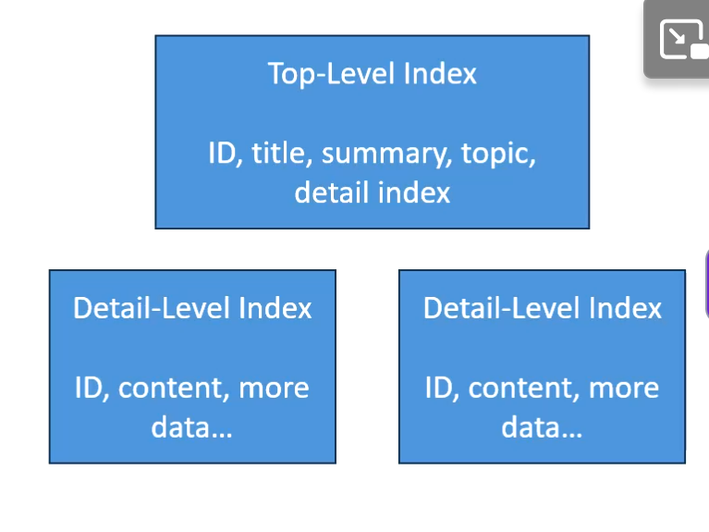
A practical example of routing a query involves a sophisticated customer support system. In this scenario, a user submits a query such as, "How do I reset my password?"
Routing the Query:
- Initial Processing: The query first runs through a natural language processing (NLP) model that converts it into an embedding vector. This is essential for semantic understanding and allows the system to find contextually similar questions in the database.
- Query Routing: Based on the embedding vector, the system can route the query to the appropriate data stores or services, such as:
  - Hierarchical Index: For organized, structured data retrieval. For instance, it might first check an FAQ section indexed hierarchically by categories (e.g., Account Management → Password Help). This helps in quickly narrowing down the relevant context.
- Hybrid Search: The system could then use a hybrid search technique to look for matching keywords and similar embeddings in real-time, ensuring that the results are both relevant and comprehensive.
When to Use a Foundation Model:
A foundation model, like OpenAI's GPT, can be integrated into this workflow for generating detailed responses. Once the system retrieves the relevant documents or FAQs, it can pass them to the foundation model to synthesize a user-friendly answer. This creates a more engaging interaction, as a foundation model can generate explanations or additional context based on the retrieved documents.
Usefulness:
- Efficiency: Routing allows for faster query handling due to the structured approach.
- Accuracy: Hierarchical indexing captures the context better, leading to more accurate retrieval.
- Enhanced User Experience: Integrating a foundation model improves the richness of the response beyond simple keyword matches.
In conclusion, utilizing a hierarchical index for structured, organized queries combined with a foundation model for generating contextual responses can significantly enhance the effectiveness and efficiency of semantic search systems in real-world applications.

In the context of an adtech domain focused on a recommendation engine, routing queries effectively and understanding when to use hierarchical indexing versus a foundation model can significantly enhance user experience and performance.
Scenario:
Imagine a user searching for recommendations based on their past behavior and interests, like "Show me ads for sports gear based on my recent searches for running shoes".
Query Routing Process:
- Initial Processing: The user's query is first processed through an embedding model (e.g., Amazon Titan) to convert it into a vector representation. This allows the system to interpret the semantic meaning of the query.
- Hierarchical Indexing: The query can then be routed to a hierarchical index. In the adtech space, this is crucial for efficiently searching through different categories of advertisements. For instance, the index might be organized into categories like "Sports", "Fashion", and "Electronics". This structured approach helps narrow down the results to the most relevant category before individual advertisements are scored and ranked.
- Foundation Model Usage: After relevant ads are retrieved based on the hierarchical index, a foundation model can be employed to generate personalized ads or to provide context. For example, the model might take additional details about the user (like preferences or demographic data) and refine the recommendations with rich descriptions or promos tailored to the user’s specific interests.
Benefits:
- Efficiency: Utilizing hierarchical indexing speeds up the retrieval process by allowing the system to focus only on relevant categories, reducing the search space.
- Enhanced Relevance: By applying a foundation model, the system can produce more tailored and nuanced ad recommendations, improving user engagement and conversion rates.
In summary, routing the query to a hierarchical index effectively narrows results, while a foundation model enriches the user’s experience by personalizing the recommendations based on retrieved data.

Opensearch as a Vector Store: Neural Plugin

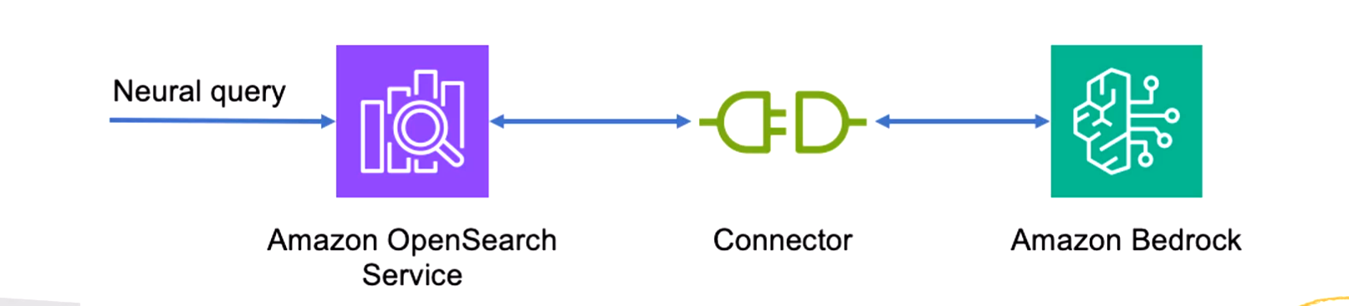
- Allows you to integrate the embedding model into an opensearch ingestion pipeline
- “Neural queries” just allow OpenSearch to accept text queries and generate embeddings under the hood for vector queries
- This is an alternative to using the built-in Bedrock Knowledge Base integration with Opensearch serverless
- The Neural plugin allows Opensearch to call your bedrock model for embeddings as part of search or ingestion.
When to Use a Neural Plugin:
A Neural Plugin is useful when you want to enhance a recommendation engine with advanced natural language processing capabilities without altering existing model parameters. This could be especially beneficial in dynamic environments where the recommendation system regularly interacts with users and needs to adapt to new queries and contexts.
Benefits:
- Streamlined Embedding Generation: By embedding the functionality directly within the system, you enable efficient generation of contextual embeddings for semantic search, reducing the need to rely on external inference engines.
- Enhanced Semantic Understanding: Neural plugins facilitate better comprehension of user queries by utilizing more sophisticated embeddings which improves the relevance of recommendations.
- Independent Model Functionality: You can augment the model's capabilities with domain-specific knowledge without the need for fine-tuning, allowing quick adaptations as new data or requirements arise.
Use-case in Adtech Domain for Recommendation Engines:
Consider an e-commerce platform using a recommendation engine that suggests ads based on user interactions. When a user searches for "running shoes", the Neural Plugin can generate embeddings that capture the semantic meaning of the query.
- Query Processing: The plugin analyzes the user's input to create an embedding that reflects their preferences and past behavior.
- Semantic Search: Using these embeddings, the recommendation engine can quickly route the query to relevant ads or product listings that match the user's intent, improving the user experience.
- Adaptive Recommendations: Over time, as more user interaction data is collected, the neural plugin can continuously update the embeddings, refining the recommendations to align more closely with user preferences.
By integrating a Neural Plugin into the recommendation system, the platform can provide more accurate and contextually relevant ads, thereby increasing user engagement and potential conversion rates.

Amazon S3 Vectors
- Where you can integrate S3 with Vectors which makes it 90% cheaper and a lot simpler
- Create a S3 Vector Bucket (to store vector data)
  - Stores both embeddings and the metadata
- Then create a vector index
  - By specifying the dimensions and the distance metric (ex. Cosine)
- Now simply store the vector embeddings (created by an embedding model ex. Bedrock) with put_vectors API
  - Include whatever metadata as required
  - Query the vector embeddings with query_vectors API to get the closest semantic hit
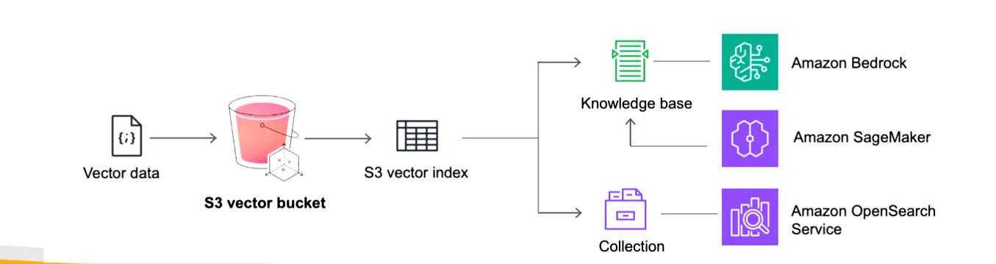
Note: Check how cheaper this one is compared to Opensearch

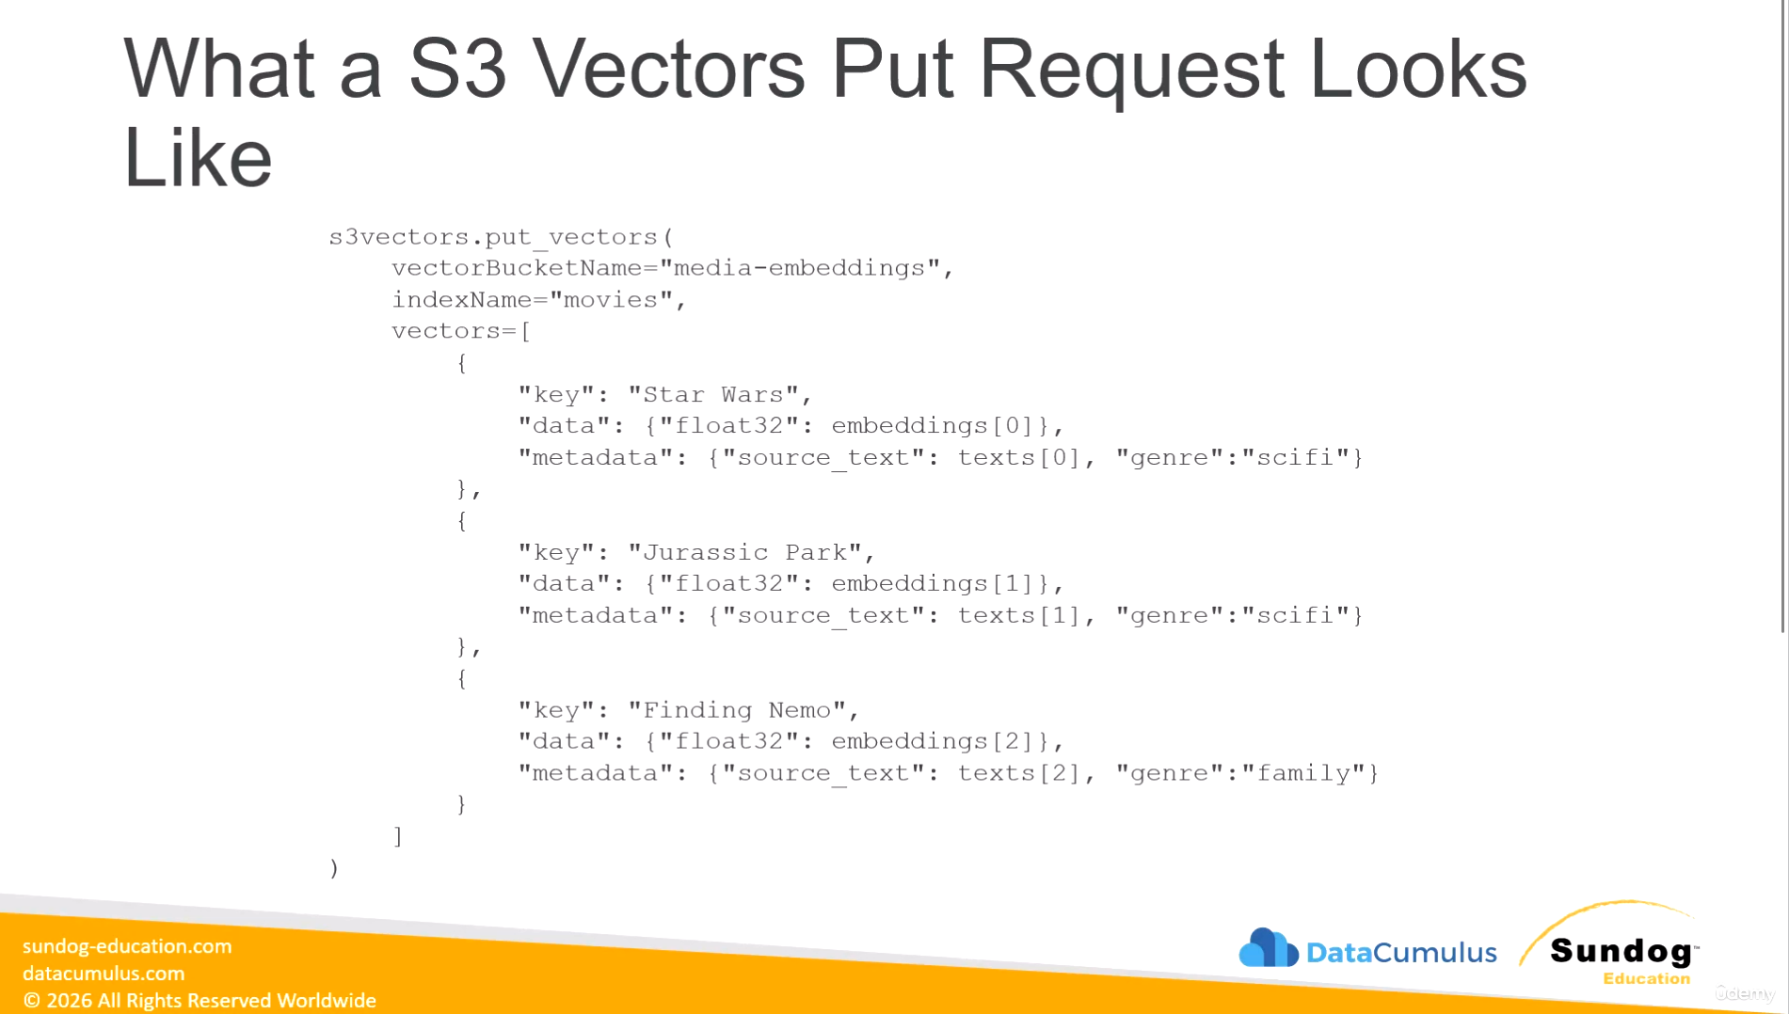

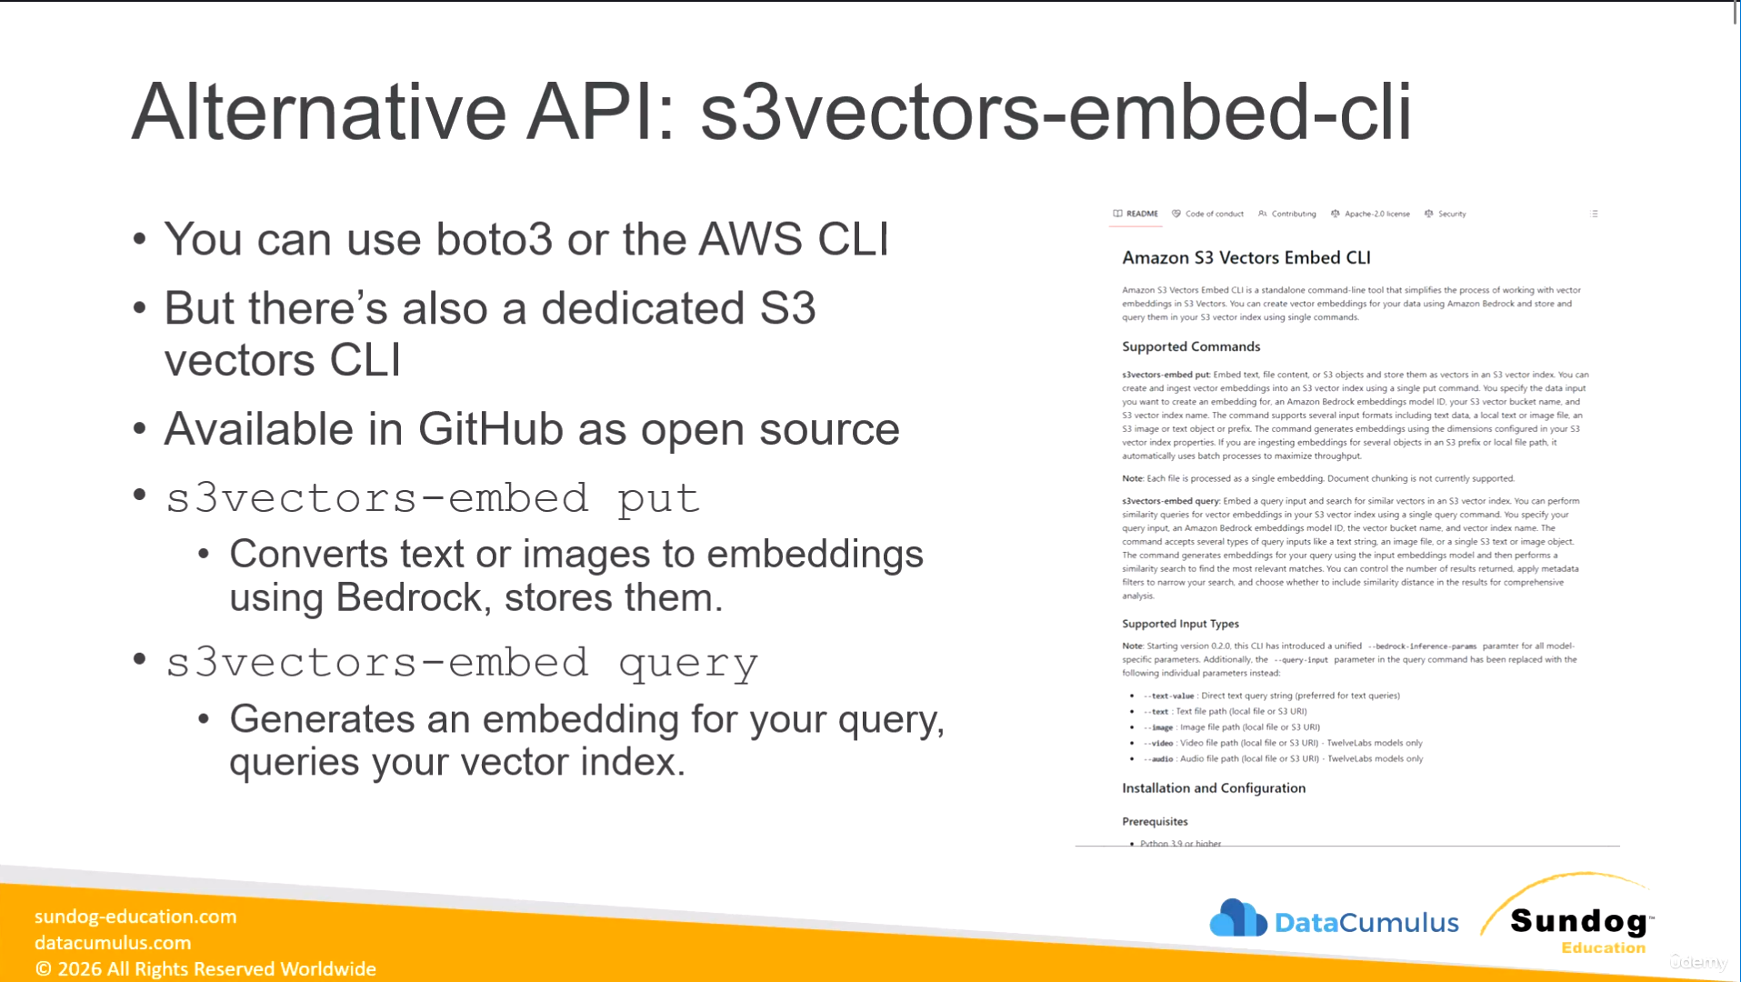
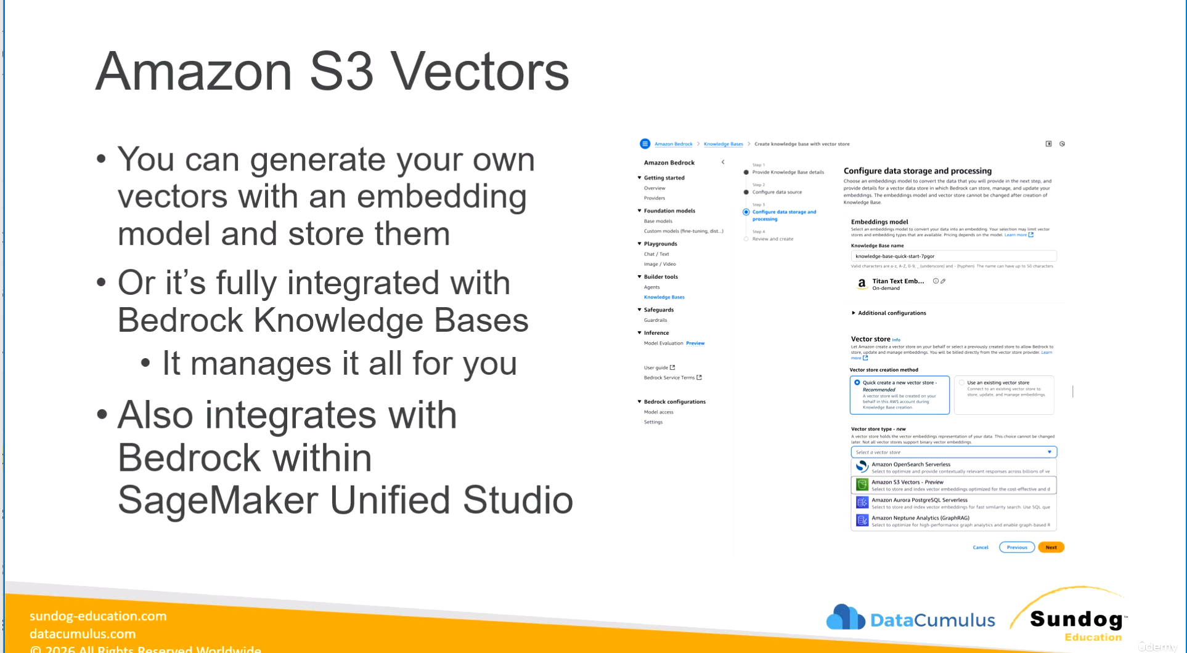

Amazon RDS
- Stands for Relational Database Service
- Is a managed DB service for DB and use SQL as a Query language
- It allows you to create databases in the cloud that are managed by AWS
  - Postgres
  - MySQL
  - MariaDB
  - Oracle
  - Microsoft SQL Server
  - IBM DB2
  - Aurora (AWS Proprietary database)
Advantage over using RDS versus deploying DB on EC2
- RDS is a managed service, it provides:
  - Automated provisioning, OS patching
  - Continuous backups and restore to specific timestamp (Point in Time restore)!
  - Monitoring Dashboards
  - Read replicas for improved read performance
  - Multi AZ setup for DR (Disaster Recovery)
  - Maintenance windows for upgrades
  - Scaling capability (vertical and horizontal)
  - Storage backed by EBS
- Note: You can’t SSH into your RDS instances (i.e. the underlying EC2 instance)

RDS – Storage Auto Scaling
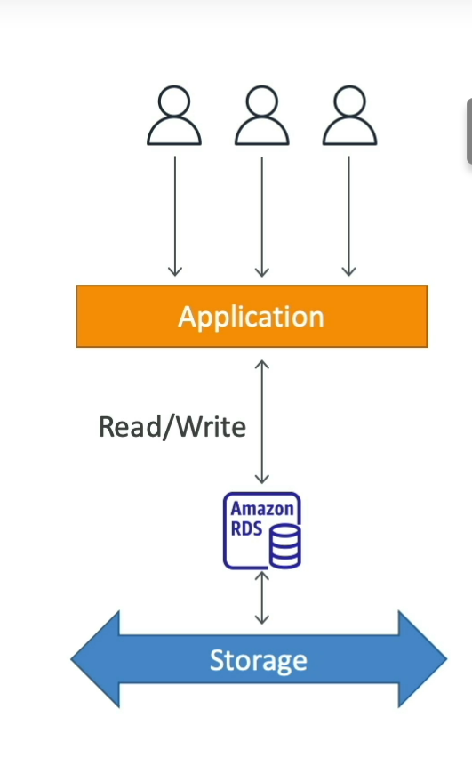
- Helps you increase storage on your RDS DB instance dynamically
- When RDS detects you are running out of free database storage, it scales automatically
- Avoid manually scaling your database storage
- You have to set Maximum Storage Threshold (i.e. the maximum limit for DB storage)
- Automatically modify storage if:
  - Free storage is less than 10% of allocated storage
  - Low-storage lasts at least5 minutes
  - 6 hours have passed since last modification
  - Useful for applications with unpredictable workloads
  - Supports all RDS database engines
Prompt:
Under what real-life scenarios do we need Storage Autoscaling in RDS? What are the trade offs? Best Practices and Pitfalls in RDS performance management
Storage auto-scaling in Amazon RDS is useful in several real-life scenarios, particularly in applications where data storage needs fluctuate frequently. Here are some common scenarios, trade-offs, best practices, and pitfalls to consider in RDS performance management:
Real-life Scenarios for Storage Auto-scaling
- Dynamic Applications: Applications that experience unpredictable workloads, such as e-commerce sites during sales, where database storage needs can spike suddenly.
- Growing Data Sets: Use cases involving logging applications or analytics databases, where the amount of data ingested over time increases significantly.
- Development and Testing: In development environments, where the workload might change frequently as APIs or features are tested.
Trade-offs
- Cost Control: While auto-scaling prevents downtime, it can lead to unexpected costs if storage grows beyond initial expectations; therefore, setting a maximum storage threshold is crucial.
- Performance Overhead: Scaling up can temporarily impact performance as the database manages the reallocation of resources.
Best Practices
- Set Maximum Storage Limits: Determine a sensible maximum storage limit to manage costs effectively.
- Monitor Usage: Regularly check storage metrics to understand the growth patterns and adjust thresholds accordingly.
- Use Multi-AZ Deployments: For disaster recovery and to enhance availability, consider using Multi-AZ configurations alongside auto-scaling.
Pitfalls
- Failure to Monitor: Not actively monitoring database performance and storage utilization can lead to unexpected spikes in costs.
- Ignoring Backup Policies: Ensure backups are still functioning as expected and manage the backup retention policy effectively during auto-scaling operations.
Utilizing RDS auto-scaling features effectively can greatly enhance application reliability and performance while providing flexibility in responding to changing data needs. It's essential to balance scaling capabilities against cost management and infrastructure performance.
In the AWS Certified Generative AI Developer Professional exam, questions related to Amazon RDS may focus on various scenarios and require a deeper understanding of both operational and architectural aspects. Here are some types of scenarios or questions you might encounter:
1. Choosing Database Engines
- Questions might ask you to select the most appropriate database engine (e.g., MySQL, PostgreSQL) based on specific use cases and requirements.
2. Performance Management
- You may face questions on strategies for optimizing performance, such as configuring read replicas, using caching, or implementing auto-scaling.
3. High Availability and Disaster Recovery
- Scenarios could include the setup of Multi-AZ deployments for high availability and how to configure backup and restore processes.
4. Cost Management
- Questions may involve cost implications of various RDS features, including the trade-offs of using storage auto-scaling versus fixed storage allocations.
5. Security Best Practices
- Expect to answer questions related to securing RDS instances, such as implementing IAM roles, encryption, and network configurations.
6. Troubleshooting Specific Issues
- You might be asked to troubleshoot performance or connectivity issues, requiring you to apply knowledge of RDS metrics and logs.
7. Complex Scenarios
- The exam includes complex scenarios where you have to integrate multiple AWS services and apply best practices, which may involve thinking critically about how RDS fits into the larger architecture.
In preparation for the exam, it's vital to work with practical scenarios in practice exams. As mentioned in the course materials, these practice exams often mirror the types of complex questions you will see on the actual test, helping you integrate the various concepts you have learned. Additionally, be prepared for new question types such as ordering and matching, which require a solid grasp of the material.
Be sure to check the AWS exam guide for specific domains and skills that will be tested, as they provide essential insights into the material areas to focus on.

Hands-On
Admin
Admin$1234!

Question: If I have to be able to access a RDS instance from SageMaker, Do both have to be in same VPC?

Note: Creating a MySQL Database is very expensive (starts $400 per month) – So DO NOT create unless absolutely required and just try-out a few options for cost modelling and check it out!!

Gen AI Use case / Application of RDS
Using RDS with S3 Document Repositories
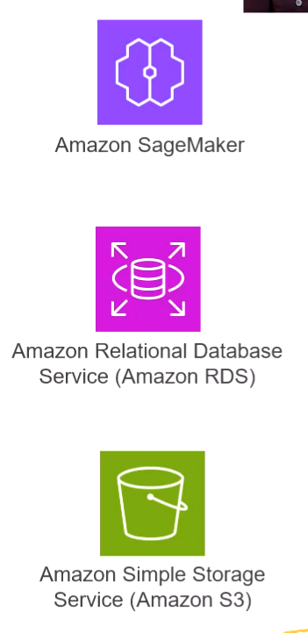
- RDS can also serve as a vector store (ex. RDS SQL Server Vector Store)
- A common pattern is to use RDS for querying structured data, which can then point to something like S3 for large unstructured data it refers to
- So it could work as below...
  - The vector store for RAG is backed by RDS
  - The data returned just points to the content in S3 that contains the actual data

Amazon Aurora
!!! Exam Impt !!!

Scenarios for Using Amazon Aurora
- Performance Needs: Aurora offers up to 5x the performance of standard MySQL and 3x that of PostgreSQL on RDS. It’s ideal for applications needing high throughput and low latency, such as online transaction processing or gaming.
- Auto-scaling Storage: Aurora's storage automatically scales as needed (starting from 10 GB), making it suitable for applications with unpredictable storage requirements. This is beneficial for web applications or services that experience fluctuating data loads.
- High Availability and Fault Tolerance: Aurora can be deployed in a Multi-AZ configuration for enhanced availability, making it suitable for critical applications requiring uptime.
- Complex Research Applications: Utilizing the pkg vector extension, Aurora serves as a vector store for similarity searches, supporting use cases involving complex filtering and analytics.
Using Aurora as a Data Warehouse for Feature Engineering
While Aurora is not primarily designed as a data warehouse, it can be used for specific analytical purposes, especially when combined with features like the pkg vector extension for managing structured and vector data together.
Certification Exam Questions
In the certification exam, you might encounter questions around:
- Performance Characteristics: Questions that examine the performance improvements provided by Aurora compared to traditional RDS options.
- Selecting the Right Database: You may need to choose between AWS services based on specific use cases, such as selecting Aurora for high-availability scenarios or use cases requiring low-latency responses.
- Understanding Extensions and Features: Questions related to extending Aurora's capabilities, including how to integrate vector operations within your queries.
Focusing on these areas will prepare you for potential scenarios presented in the certification exam. Make sure to review Aurora’s architecture and operational features in conjunction with practice questions to solidify your understanding.

Hands-On
Has MySQL and PostgreSQL Compatible options

Questions
- When would you allow “public access” to the database ?
- What is “Read Replica Write Forwarding”
- What all IAM roles are needed?
  - While creating the database
  - For the service user to connect to the database
  - What is ReadReplicaScalingPolicy and why is it needed ?
    - To enable autoscaling?

Amazon Aurora and PGVector Extension i.e Aurora serving as a Vector Store
- Pgvector extension
  - Creates a new “vector” column type
  - Can compute cosine, L2, or inner product distances
  - Can do similarity search with OVF or HNSW
  - Also adds vector operators for SQL
    - This gives it an advantage over OpenSearch if you need complex filtering logic and stuff
  - Allows storage of structured and vector data in the same place
  - Can be appropriate for small / medium RAG systems with mostly structured data

Question
- When would you use Aurora as Vector Store?
- How does Aurora compare with OpenSearch as a Vector Store?
- Why can’t any relational database be used as a Vector Store?
- Can a NoSQL Database be used as a Vector Store?
- Difference between a graph database and a Vector Store?
- What are the factors to consider when selecting a database? vector datastore? a graph database?
- Which database is best for streaming real-time data? for audio? for video?
- How is text data / transcript stored when the data is Audio / Video?

Amazon Dynamo DB -NoSQL Serverless Database

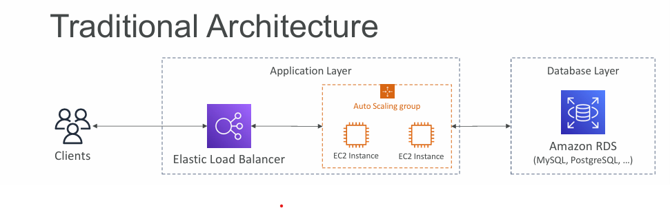
- Traditional applications leverage RDBMS Databases
- These databases have the SQL Query language
- Strong requirements about how the data should be modelled
- Ability to do query joins, aggregations, complex computations
- Vertical scaling (i.e. getting a more powerful CPU/ RAM/ IO)
- Horizontal Scaling (increasing reading capability by adding EC2 / RDS Read Replicas)
NoSQL Databases
- Are non-relational databases and are distributed
- Ex. MongoDB, DynamoDB
- NoSQL databases do not support query joins (or just limited support)
- All the data that is needed for a query is present in one row
- NoSQL databases don’t perform aggregations such as AVG, SUM, etc.
- NoSQL Databases scale horizontally
- The selection of a NoSQL database is just dependent on the requirement to model data differently and think about user queries differently
Amazon DynamoDB
- Is a fully managed, highly available DB with replication across multiple AZs
- Is a NoSQL Database, NOT a relational DBMS
- Scales to massive workloads, and is a distributed database
- Processes millions of requests per second, trillions or rows, 100s of TB of storage
- Is fast and consistent in performance (low latency on retrieval)
- Integrated with IAM for security, authorization and administration
- Enables event driven programming with DynamoDB Streams
- Is Low cost and provide auto-scaling capabilities
- Also has Standard and Infrequent Access (IA) Table class for different tiers
DynamoDB Basics
- DynamoDB is made up of tables
- Each table has a primary key (must be decided at creation time)
- Each table can have infinite number of items (=rows)
- Each item has attributes (which can be null and also added over time)
- Maximum size of an item is 400KB (which is a limitation)
- Datatypes supported:
  - Scalar types – String, Number, Binary, Boolean, Null
  - Document types – List, Map
  - Set Types – String Set, Number Set, Binary Set
DynamoDB – Primary Key
- Option 1: Partition Key (uses HASH strategy)
  - Partition Key must be unique for each item
  - Partition key must be “diverse” so that the data is distributed
  - Example: “User_ID” for a users table
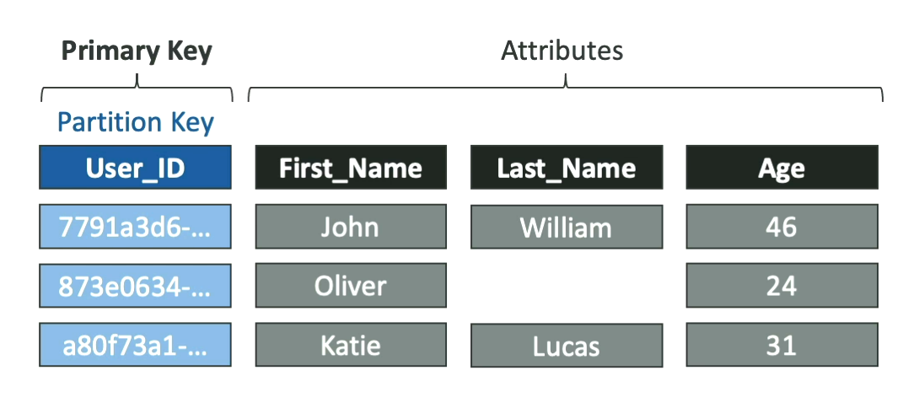
- Option 2: Partition Key + Sort Key (HASH + RANGE)
  - The combination must be unique for each item (row)
  - Data is grouped by the partition key
  - Example: usesrs-games table, has USER_ID for partition key and GAME_ID for Sort key
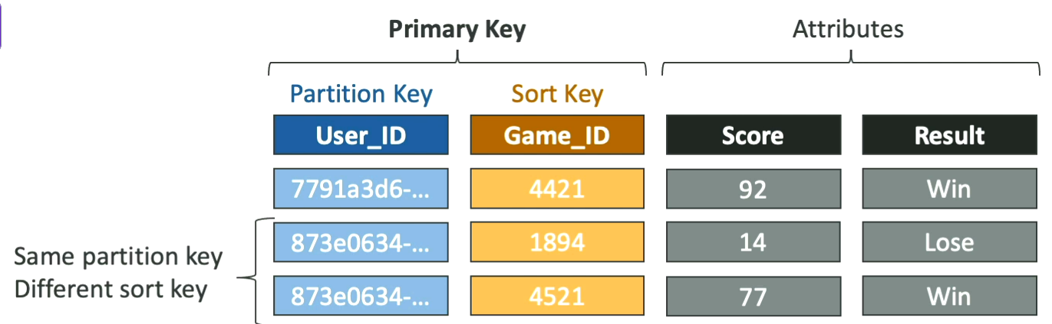

** Exam Important **
DynamoDB Partition Keys (Exercise)
- We’re building a movie database
- What is the best partition key to maximize data distribution
  - Movie_id
  - Producer_name
  - Leader_actor_name
  - Movie_language
- “movie_id” has the highest cardinality so it is a good candidate
- Similarly “movie_language” doesn’t take many values and may be skewed towards English so its not a great choice for the partition key
Note: Choosing the partition key – always go for the one with highest cardinality so that the dataset is as diverse as it can be.

DynamoDB Hands-on
Creating a Table
- Input table name, table class,
Note: Understand how the capacity calculator works!!

- Create an item with partition key + sort key

Amazon DynamoDB – WCU and RCU
i.e. Read / Write Capacity Modes in DynamoDB
Helps control how we manage the table’s capacity (read/write throughput)
- Two Modes
  - Provisioned Mode
    - You specify the number of reads/ writes per second
    - You need to plan capacity beforehand
    - Pay for provisioned read and write capacity units
  - On-demand mode (default)
    - Read / writes automatically scale up/down with the workloads
    - No capacity planning is needed
    - Pay for what you use , is more expensive
  - You can switch between two modes every 24 hours.

DynamoDB with GenAI
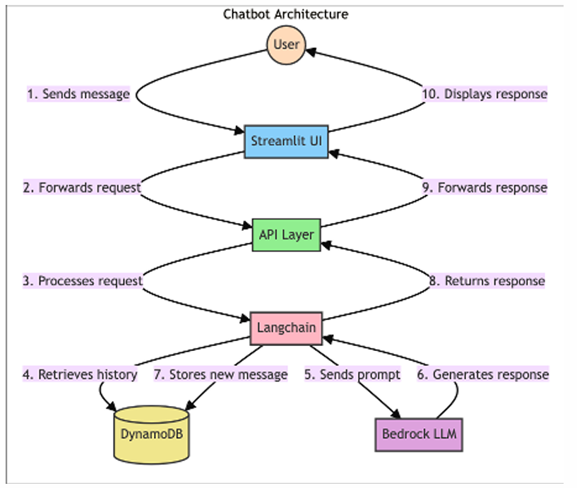
- It is not a vector store, though we can store vectors we cannot search for them in DynamoDB
- It can still serve your model with near real-time data
- One specific application is storing short- and long-term memory for the AI Agents.
- For example, if we need to store and retrieve our chat histories and hence need to persist them over time (for ex. Chatgpt conversation history) which is long-term memory – DynamoDB is the place
- If we want to store user preferences
- Or DynamoDB can be a solution for context awareness in a Chatbot

DynamoDB and OpenSearch
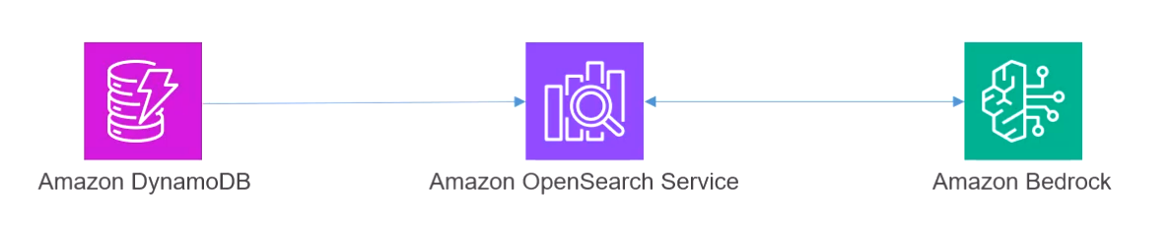
- Zero-ETL Integration with OpenSearch
- You can create a pipeline from DynamoDB to OpenSearch
- Then use OpenSearch as your vector store for Bedrock
- This is a way to incorporate DynamoDB into your Knowledge Bases

Keeping your Vector Store Up to Date
- We need some way to keep the vector store in sync with new and changed data. Now, how do we do that?
  - Through Incremental updates
  - Real-time change detection
  - Automated synchronization
  - Scheduled refresh pipelines
- We use EventBridge for that!!
Given below is a typical architecture to handle this...
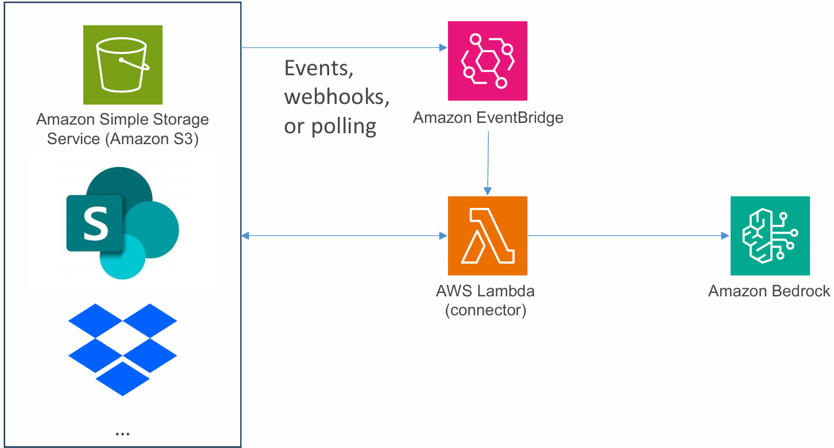
Here the eventbridge polls the data sources for events i.e. updates triggering a lambda function to refresh the embeddings, vectors and etc.
Vector Index Maintenance
Now, overtime Drift and Fragmentation can become issues in terms of maintaining the vector indices in the data store thus affecting the performance.
- You could use EventBridge to schedule a periodc trigger to rebuild your indices
- This could in turn use AWS batch to queue up a job that
  - Creates new embeddings
  - Creates a new vector DB
  - Validates it
  - Swaps from the old to the new

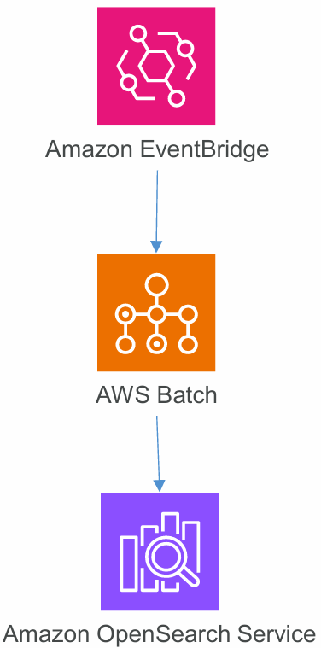

Amazon EventBridge plays a crucial role in keeping vector stores up to date by enabling real-time event-driven architectures. Here’s how it works in steps:
- Change Detection: EventBridge listens for changes in your data source. This could involve events from services like S3, webhooks from third-party systems, or scheduled polling that detects updates.
- Event Handling: Once EventBridge detects a change, it can kick off a serverless function, typically an AWS Lambda function, which retrieves the updated data.
- Data Processing: This Lambda function can process the changed data (e.g., generate embeddings or update the vector store) using the new information.
- Flexibility and Reliability: By using an event-driven architecture, you can ensure that data is processed even if downstream systems (like data warehouses or CRM systems) are temporarily unavailable, as the events can be queued for later processing.
- Integration with Other Services: EventBridge can work with various AWS services and frameworks, ensuring that your architecture can respond to changes dynamically and efficiently.
Overall, EventBridge is essential for maintaining the accuracy and relevance of your vector store as new data is added or existing data is modified or deleted.

AWS Batch can be beneficial in managing and processing large volumes of jobs in batch mode, particularly when dealing with large datasets for vector updates. Here’s how it can be combined with EventBridge and Lambda for effective vector store maintenance:
- EventBridge for Change Detection: EventBridge can monitor changes in the data source for real-time updates. When a change is detected, it can trigger a workflow.
- Lambda for Light Processing: For immediate and lightweight processing, Lambda functions can quickly handle updates, making necessary adjustments to the vector store.
- AWS Batch for Heavy Processing: For more complex or resource-intensive tasks, AWS Batch can schedule jobs that handle larger batches of updates. This allows for scalable processing without overloading Lambda's execution time and memory limits.
This combination can create a robust architecture that effectively manages vector store updates.
Regarding the phrase "Swaps from the old to the new" in the context of vector index maintenance, it typically refers to the process of replacing an old version of the index or data with a newly updated version. This ensures that applications always access the most recent and relevant data efficiently. By leveraging event-driven architectures and batch processing, you can facilitate this swap with minimal disruption and delay in data availability.

Re-Ranker Modules in Bedrock
- To improve the quality of RAG context retrieved from the vector stores
- Helps / attempts to improve the relevance of retrieved results for RAG from your KB / Vector Store
- Calculates relevance of chunks to the query, orders results accordingly
- There is a Rerank operation in the Bedrock API that can be used to rank whatever documents we want relative to a query
- You can also specify a reranker model when hitting your knowledgebase
- Currently we can choose from Amazon of Cohere models in limited regions (to be verified)

Amazon S3
Amazon – Storage Classes
- Amazon S3 Standard – General Purpose
- Amazon S3 Standard – Infrequent Access (IA)
- Amazon S3 One Zone – Infrequent Access
- Amazon S3 Glacier Instant Retrieval
- Amazon S3 Glacier Flexible Retrieval
- Amazon S3 Glacier Deep Archive
- Amazon S3 Intelligent Tiering

Note: When we create an object in Amazon S3, we can choose its class, can also modify its storage class manually or using S3 Lifecycle configurations to move objects automatically between storage classes

Amazon S3 Durability and Availability

Amazon S3 Lifecycle Rules

Amazon S3 – Replication

S3 Encryption

S3 Access Logs

S3 Access Points

Section 4: Agentic AI

Introduction
Agentic AI refers to systems that not just generate responses, but also can reason, plan, take action, collaborate, and integrate with real tools and data across organisation.

Section 5: Operational Efficiency and Optimization

Section 6: Managing Models with SageMaker AI

Section 7: More Tools for Building AI Applications

Section 8: Governance and QA

Section 9: Security, Identity, and Compliance

Section 10: Analytics Services you should know

Section 11: Compute, Container, and Customer Engagement Services You Should Know

Section 12: Database Services You Should Know

Section 13: Developer Tools Services You Should Know

Section 14: Machine Learning Services You Should Know

Section 15: Management and Governance Services You Should Know

Section 16: Migration and Transfer Services You Should Know

Section 17: Networking and Content Delivery Services You Should Know

Section 18: Storage Services You Should Know

Section 19: Notes on GenAI Architectural Trade-offs

References

